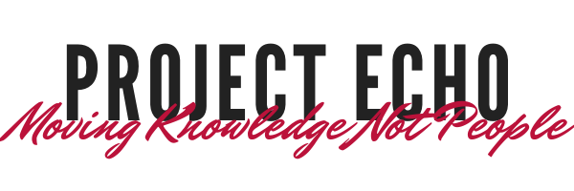

**Clinic Schedule Coming Soon!**

**Free CME Credits Awarded**

*With completion of survey per session

If you have any questions or discussion points that you would like addressed during the ECHO sessions, please email them to [keefed@upstate.edu](mailto:keefed@upstate.edu). The session will be audio and video recorded. Your participation confirms your consent to this recording/photography. To ensure HIPAA compliance, patient information must remain de-identified for presentation during clinic.

To join via video conferencing system (i.e. SIP or H.323) please contact Deidre Keefe at [keefed@upstate.edu](mailto:keefed@upstate.edu) for connection information

**New Monthly ECHO Clinic Series**

**BURN ECHO sessions**

**3rd Tuesday of every month**

**12:00 PM – 1:00 PM**

**Clinics begin May 18th 2021**

**First Session – PTSD and the Burn Patient**

**Login Information**

**Join Zoom from PC, Mac, iOS or Android**

[https://echo.zoom.us/j/329312363](https://echo.zoom.us/j/329312363?pwd=dllwc0JsVnQvUCtidGdYZzh6VWZzUT09)

**Joining by phone ONLY:**

+1 646 558 8656 US (New York)

**Meeting ID:** 329 312 363

**Password:** ECHO