**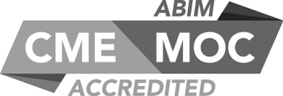****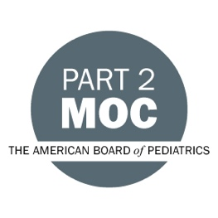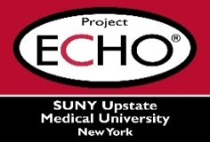**

**SUNY Upstate Project ECHO® (Extension for Community Healthcare Outcomes)**

**SUNY Upstate Primary Care Family Medicine TeleECHO**

***Addressing Concerning Learner Behaviors in the Clinical Learning Environment***

**SUNY Upstate**

**Syracuse, NY**

**Tuesday, November 7, 2023**

**12-1 PM**

**TARGET AUDIENCE:**Physicians, Physicians Assistants, Nurse Practitioners, Registered Nurses, Community Health Care Workers, Pre-Hospital Healthcare workers, Pharmacists, Emergency Care Providers, Preceptors

**PRESENTERS:**

Ann Botash, MD

**OBJECTIVES:**   
Participants will be able to:

* Discuss an example of common concerning learner behavior (student tardiness) and determine if the response constitutes mistreatment.
* Identify opportunities to improve learner acceptance of the feedback, such as with frame-based feedback.
* Share experiences and best practices for feedback in cases of learner irresponsible or unprofessional behaviors.

**ACCREDITATION:** SUNY Upstate Medical University is accredited by the Accreditation Council for Continuing Medical Education (ACCME) to provide continuing education for physicians.

**CREDIT DESIGNATION**: SUNY Upstate Medical University designates this live activity for a maximum of 1.0 *AMA PRA Category 1 Credits™.* Physicians should claim only the credit commensurate with the extent of their participation in the activity.

**MOC**: Successful completion of this CME activity, which includes participation in the evaluation component, enables the learner to earn up to 1 MOC points in the American Board of Pediatrics’ (ABP) Maintenance of Certification (MOC) program. It is the CME activity provider’s responsibility to submit learner completion information to ACCME for the purpose of granting ABP MOC credit.”

**PLANNER DISCLOSURES**: A. Botash and K. Donovan do not have relevant financial relationships with ineligible companies.

**SPEAKER DISCLOSURE**: A. Botash, do not have relevant financial relationships with ineligible companies.

**MITIGATION:** All listed relevant financial relationships have been mitigated.

**COMMERCIAL SUPPORT:** No commercial is received for this CME program.