**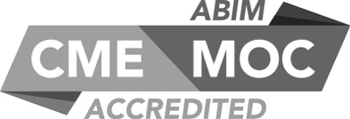****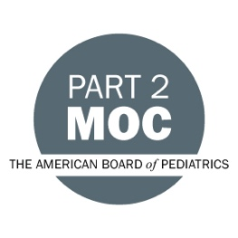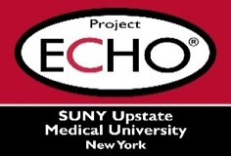**

**SUNY Upstate Project ECHO® (Extension for Community Healthcare Outcomes)**

**SUNY Upstate Burn TeleECHO**

***A Patient’s Perspective: Care, Communication, and Compassion***

**SUNY Upstate**

**Syracuse, NY**

**Tuesday, November 14, 2023**

**Noon - 1 PM**

**TARGET AUDIENCE:**Physicians, Physicians Assistants, Nurse Practitioners, Registered Nurses, Community Health Care Workers, Pre-Hospital Healthcare workers, Pharmacists, Emergency Care Providers, Preceptors

**PRESENTERS:**

Monica Gerrek, PhD

Andrea Hope Rubin, BA

**OBJECTIVES:**   
Participants will be able to:

* Explain the importance of an interdisciplinary team approach that emphasizes cohesive messaging.
* Illustrate the value of treating a patient as a whole, not just as an immediate problem.
* Describe the impact verbal and non-verbal cues have on patients.
* Reflect on what it’s like navigating the non-trauma medical community as a severely disfigured person and how medical professionals’ reactions can affect their patients.

**ACCREDITATION:** SUNY Upstate Medical University is accredited by the Accreditation Council for Continuing Medical Education (ACCME) to provide continuing education for physicians.

**CREDIT DESIGNATION**: SUNY Upstate Medical University designates this live activity for a maximum of 1.0 *AMA PRA Category 1 Credits™.* Physicians should claim only the credit commensurate with the extent of their participation in the activity.

**PLANNER DISCLOSURES**: J. Marraffa, K. Donovan do not have relevant financial relationships with ineligible companies.

**SPEAKER DISCLOSURE**: M. Gerrek, A. Hope Rubin do not have relevant financial relationships with ineligible companies.

**MITIGATION:** All listed relevant financial relationships have been mitigated.

**COMMERCIAL SUPPORT:** No commercial is received for this CME program.