**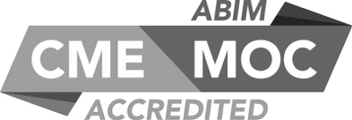****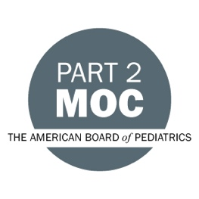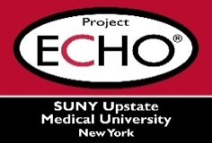**

**SUNY Upstate Project ECHO® (Extension for Community Healthcare Outcomes)**

**SUNY Upstate Toxicology TeleECHO**

***TikTok and Poison Centers: Do they Intersect?***

**SUNY Upstate**

**Syracuse, NY**

**Tuesday, November 21, 2023**

**Noon - 1 PM**

**TARGET AUDIENCE:**Physicians, Physicians Assistants, Nurse Practitioners, Registered Nurses, Community Health Care Workers, Pre-Hospital Healthcare workers, Pharmacists, Emergency Care Providers, Preceptors

**PRESENTERS:**

Jeanna Marraffa, PHARMD, MPH, DABAT, FAACT

**OBJECTIVES:**

* Describe how recent social media trends have resulted in poisoning cases.
* Discuss the potential dangers of social media trends.
* Discuss how the poison center can be a resource as emerging trends occur.

**ACCREDITATION:** SUNY Upstate Medical University is accredited by the Accreditation Council for Continuing Medical Education (ACCME) to provide continuing education for physicians.

**CREDIT DESIGNATION**: SUNY Upstate Medical University designates this live activity for a maximum of 1.0 *AMA PRA Category 1 Credits™.* Physicians should claim only the credit commensurate with the extent of their participation in the activity.

**PLANNER DISCLOSURES**: J. Marraffa, K. Donovan do not have relevant financial relationships with ineligible companies.

**SPEAKER DISCLOSURE**: J. Marraffa does not have relevant financial relationships with ineligible companies.

**MITIGATION:** All listed relevant financial relationships have been mitigated.

**COMMERCIAL SUPPORT:** No commercial is received for this CME program.