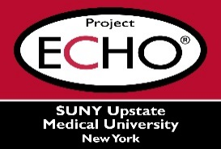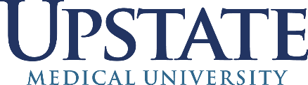

**SUNY Upstate Project ECHO® (Extension for Community Healthcare Outcomes)**

**SUNY Upstate Obstetrics and Gynecology TeleECHO**

***RSV Prevention Updates: Pregnant & Neonatal Populations***

**SUNY Upstate**

**Syracuse, NY**

**Tuesday, November 26, 2024**

**Noon - 1 PM**

**TARGET AUDIENCE:**Physicians, Physicians Assistants, Nurse Practitioners, Registered Nurses, Community Health Care Workers, Pre-Hospital Healthcare workers, Pharmacists, Emergency Care Providers

**PRESENTER:**   
Joseph Domachowske, MD

Miriam Bernstein, MD

Matt O’Connor, MD

Kendra Rector, BSN, RNC-OB, C-EFM

Cathy Narcavage-Bradley DNP, RN, PHNA-BC

**OBJECTIVES:**   
Participants will be able to:

* Discuss updates and current recommendations for RSV prevention in pregnancy and in the neonatal period.
* Review an overview of RSV vaccine research and RSV prevention in pregnancy and the neonate data to date.
* Locate RSV prevention resources for patients on the vaccine and clinical guidance for providers.

**ACCREDITATION:** SUNY Upstate Medical University is accredited by the Accreditation Council for Continuing Medical Education (ACCME) to provide continuing education for physicians.

**CREDIT DESIGNATION**: SUNY Upstate Medical University designates this live activity for a maximum of 1.0 *AMA PRA Category 1 Credits™.* Physicians should claim only the credit commensurate with the extent of their participation in the activity.

**PLANNER DISCLOSURES**: C. Narcavage-Bradley, K. Donovan do not have relevant financial relationships with ineligible companies.

**SPEAKER DISCLOSURE**: C. Narcavage-Bradley, M. Bernstein, M. O’Connor, K. Rector do not have relevant financial relationships with ineligible companies.

**MITIGATION:** All listed relevant financial relationships have been mitigated.

**COMMERCIAL SUPPORT:** No commercial is received for this CME program.