**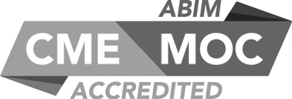****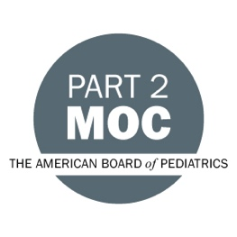**

**SUNY Upstate Project ECHO® (Extension for Community Healthcare Outcomes)**

**SUNY Upstate Primary Care Family Medicine TeleECHO**

***Optimal Telehealth Environment Setup for Behavioral Health Clinicians***

**SUNY Upstate**

**Syracuse, NY**

**Monday, April 21, 2025**

**12-1 PM**

**TARGET AUDIENCE:**Physicians, Physicians Assistants, Nurse Practitioners, Registered Nurses, Community Health Care Workers, Pre-Hospital Healthcare workers, Pharmacists, Emergency Care Providers, Preceptors

**PRESENTERS:**

Raymond Barrett, CEO

**OBJECTIVES:**   
Participants will be able to:

* Identify key elements of an effective telehealth office environment, including privacy, visual aesthetics, and lighting.
* Implement strategies to optimize audio and video quality for telehealth sessions, addressing common issues such as echo, reverberation, and connectivity.
* Apply HIPAA-compliant methods and technological solutions to ensure privacy and minimize distractions during virtual counseling options.

**ACCREDITATION:** SUNY Upstate Medical University is accredited by the Accreditation Council for Continuing Medical Education (ACCME) to provide continuing education for physicians.

**CREDIT DESIGNATION**: SUNY Upstate Medical University designates this live activity for a maximum of 1.0 *AMA PRA Category 1 Credits™.* Physicians should claim only the credit commensurate with the extent of their participation in the activity.

**MOC:** Successful completion of this CME activity, which includes participation in the evaluation component, enables the participant to earn

-one MOC point in the American Board of Internal Medicine's (ABIM) Maintenance of Certification (MOC) program; and

-one MOC point in the American Board of Pediatrics’ (ABP) Maintenance of Certification (MOC) program.

It is the CME activity provider's responsibility to submit participant completion information to ACCME for the purpose of granting ABIM or ABP MOC credit.

**PLANNER DISCLOSURES**: K. Donovan, A. Botash do not have relevant financial relationships with ineligible companies.

**SPEAKER DISCLOSURE**: R. Barrett does not have any relevant financial relationships with ineligible companies.

**MITIGATION:** All listed relevant financial relationships have been mitigated.

**COMMERCIAL SUPPORT:** No commercial is received for this CME program.