
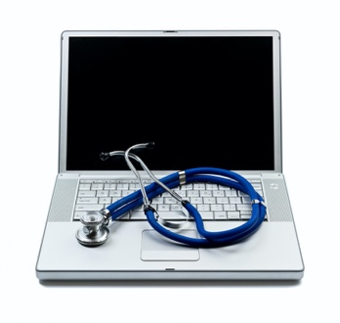


April is Donate Life Month!
Join us for a special ECHO Series
Focusing on Transplant

Mondays, April 19th and May 3rd, 2021
12:00 PM – 1:00 PM
Clinic Specialist: Reza Saidi, MD & Eman Shaban, MD
These sessions will both contain different information and will help address transplant areas that PCP are able to manage in their offices including; tests to run, how to read/interpret certain lab results, medications that can be beneficial, management after transplant, living donations, transplant candidacy, etc.

Login Information
Join Zoom from PC, Mac, iOS or Android:
https://echo.zoom.us/j/735931981

Joining by phone ONLY:
+1 646 558 8656 US (New York)
Meeting ID: 735 931 981
Password: ECHO
To join via video conferencing system (i.e. SIP or H.323) please contact Deidre Keefe at keefed@upstate.edu for connection information

If you have any questions or discussion points that you would like addressed during this ECHO session please email them to keefed@upstate.edu. The session will be audio and video recorded. Your participation confirms your consent to this recording/photography. To ensure HIPAA compliance, patient information must remain de-identified for presentation during clinic.

