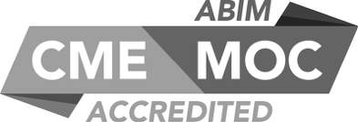

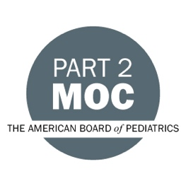
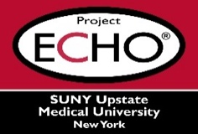

SUNY Upstate Project ECHO® (Extension for Community Healthcare Outcomes)
SUNY Upstate Burn TeleECHO
A Patient’s Perspective: Care, Communication, and Compassion
SUNY Upstate
Syracuse, NY
Tuesday, November 14, 2023
Noon - 1 PM
TARGET AUDIENCE:
Physicians, Physicians Assistants, Nurse Practitioners, Registered Nurses, Community Health Care Workers, Pre-Hospital Healthcare workers, Pharmacists, Emergency Care Providers, Preceptors

PRESENTERS:
Monica Gerrek, PhD
Andrea Hope Rubin, BA

OBJECTIVES:
Participants will be able to:
- Explain the importance of an interdisciplinary team approach that emphasizes cohesive messaging.
- Illustrate the value of treating a patient as a whole, not just as an immediate problem.
- Describe the impact verbal and non-verbal cues have on patients.
- Reflect on what it’s like navigating the non-trauma medical community as a severely disfigured person and how medical professionals’ reactions can affect their patients.

ACCREDITATION: SUNY Upstate Medical University is accredited by the Accreditation Council for Continuing Medical Education (ACCME) to provide continuing education for physicians.
CREDIT DESIGNATION: SUNY Upstate Medical University designates this live activity for a maximum of 1.0 AMA PRA Category 1 Credits™. Physicians should claim only the credit commensurate with the extent of their participation in the activity.
PLANNER DISCLOSURES: J. Marraffa, K. Donovan do not have relevant financial relationships with ineligible companies.
SPEAKER DISCLOSURE: M. Gerrek, A. Hope Rubin do not have relevant financial relationships with ineligible companies.
MITIGATION: All listed relevant financial relationships have been mitigated.
COMMERCIAL SUPPORT: No commercial is received for this CME program.

