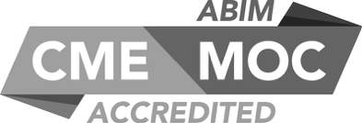

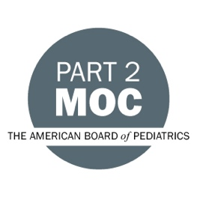
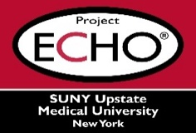

SUNY Upstate Project ECHO® (Extension for Community Healthcare Outcomes)
SUNY Upstate Primary Care Family Medicine TeleECHO
Best practices for improving interprofessional communication
SUNY Upstate
Syracuse, NY
Tuesday, December 5, 2023
12-1 PM
TARGET AUDIENCE:
Physicians, Physicians Assistants, Nurse Practitioners, Registered Nurses, Community Health Care Workers, Pre-Hospital Healthcare workers, Pharmacists, Emergency Care Providers, Preceptors

PRESENTERS:
Jocelyn Young, DO, MS(ED), FAAFP

OBJECTIVES:
Participants will be able to:
- Explore an example of interprofessional communication and reflect on effectiveness and professionalism.
- Identify personal steps to improving emotional intelligence and how it relates to interprofessional communication.
- Discuss and share best practices for responding to lapses in professionalism in communication.

ACCREDITATION: SUNY Upstate Medical University is accredited by the Accreditation Council for Continuing Medical Education (ACCME) to provide continuing education for physicians.
CREDIT DESIGNATION: SUNY Upstate Medical University designates this live activity for a maximum of 1.0 AMA PRA Category 1 Credits™. Physicians should claim only the credit commensurate with the extent of their participation in the activity.
MOC: Successful completion of this CME activity, which includes participation in the evaluation component, enables the participant to earn
-one MOC point in the American Board of Internal Medicine's (ABIM) Maintenance of Certification (MOC) program; and
-one MOC point in the American Board of Pediatrics’ (ABP) Maintenance of Certification (MOC) program.
It is the CME activity provider's responsibility to submit participant completion information to ACCME for the purpose of granting ABIM or ABP MOC credit.
PLANNER DISCLOSURES: J. Young and K. Donovan do not have relevant financial relationships with ineligible companies.
SPEAKER DISCLOSURE: J. Young, do not have relevant financial relationships with ineligible companies.
MITIGATION: All listed relevant financial relationships have been mitigated.
COMMERCIAL SUPPORT: No commercial is received for this CME program.

