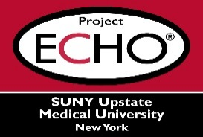


SUNY Upstate Project ECHO® (Extension for Community Healthcare Outcomes)

SUNY Upstate REACH TeleECHO
Treatment of Anxiety and Depression in Older Adults
SUNY Upstate
Syracuse, NY
Wednesday, May 1, 2024
Noon - 1 PM

TARGET AUDIENCE:
Physicians, Physicians Assistants, Nurse Practitioners, Registered Nurses, Community Health Care Workers, Pre-Hospital Healthcare workers, Pharmacists, Emergency Care Providers

PRESENTER:
Kristina Zdanys, MD

OBJECTIVES:
Participants will be able to:

- Describe the approach to the work-up of behavioral and psychological symptoms in dementia (BPSD).
- Summarize non-pharmacological approaches to treatment of BPSD.
- Identify off-label pharmacological approaches for treatment of BPSD.

ACCREDITATION: SUNY Upstate Medical University is accredited by the Accreditation Council for Continuing Medical Education (ACCME) to provide continuing education for physicians.
CREDIT DESIGNATION: SUNY Upstate Medical University designates this live activity for a maximum of 1.0 AMA PRA Category 1 Credits™. Physicians should claim only the credit commensurate with the extent of their participation in the activity.
PLANNER DISCLOSURES: K. Zadanys and K. Donovan do not have relevant financial relationships with ineligible companies.
SPEAKER DISCLOSURE: K. Zdanys does not have relevant financial relationships with ineligible companies.
MITIGATION: All listed relevant financial relationships have been mitigated.
COMMERCIAL SUPPORT: No commercial is received for this CME program.

