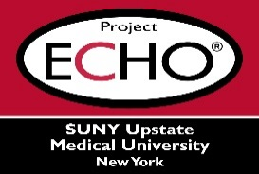


SUNY Upstate Project ECHO® (Extension for Community Healthcare Outcomes)

SUNY Upstate Emergency Medicine TeleECHO
Burn Shock and Hemodynamic Monitoring
SUNY Upstate
Syracuse, NY
Tuesday, January 20, 2026
12-1 PM

TARGET AUDIENCE:
Physicians, Physicians Assistants, Nurse Practitioners, Registered Nurses, Community Health Care Workers, Pre-Hospital Healthcare workers, Pharmacists, Emergency Care Providers

PRESENTER:
Tamara Roberts, MSN, RN

OBJECTIVES:
Participants will be able to:
- Define burn shock
- Describe pathophysiology
- Apply monitoring strategies
- Identify resuscitation endpoints

ACCREDITATION: SUNY Upstate Medical University is accredited by the Accreditation Council for Continuing Medical Education (ACCME) to provide continuing education for physicians.

CREDIT DESIGNATION: SUNY Upstate Medical University designates this live activity for a maximum of 1.0 AMA PRA Category 1 Credits™. Physicians should claim only the credit commensurate with the extent of their participation in the activity.

PLANNER DISCLOSURES: None of the planners have relevant financial relationships with ineligible companies.
SPEAKER DISCLOSURE: R. Roberts does not have relevant financial relationships with ineligible companies.
COMMERCIAL SUPPORT: No commercial is received for this CME program.

