**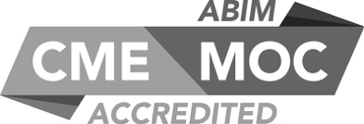****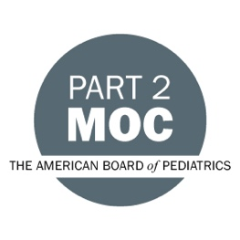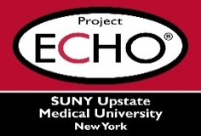**

**SUNY Upstate Project ECHO® (Extension for Community Healthcare Outcomes)**

**SUNY Upstate Primary Care Family Medicine TeleECHO**

***Professionalism Problems in Residency: Opportunities for Intervention***

**SUNY Upstate**

**Syracuse, NY**

**Tuesday, February 6, 2024**

**12-1 PM**

**TARGET AUDIENCE:**Physicians, Physicians Assistants, Nurse Practitioners, Registered Nurses, Community Health Care Workers, Pre-Hospital Healthcare workers, Pharmacists, Emergency Care Providers, Preceptors

**PRESENTERS:**

Katherine Holmes, MD

**OBJECTIVES:**   
Participants will be able to:

* Identify professionalism problems in residents using an example and reflect on professionalism lapses using previous experiences as medical educators.
* Create a structured plan for responding to professionalism lapses during residency.
* Share resources for diagnosing and managing professionalism lapses in residency.

**ACCREDITATION:** SUNY Upstate Medical University is accredited by the Accreditation Council for Continuing Medical Education (ACCME) to provide continuing education for physicians.

**CREDIT DESIGNATION**: SUNY Upstate Medical University designates this live activity for a maximum of 1.0 *AMA PRA Category 1 Credits™.* Physicians should claim only the credit commensurate with the extent of their participation in the activity.

**MOC:** Successful completion of this CME activity, which includes participation in the evaluation component, enables the participant to earn

-one MOC point in the American Board of Internal Medicine's (ABIM) Maintenance of Certification (MOC) program; and

-one MOC point in the American Board of Pediatrics’ (ABP) Maintenance of Certification (MOC) program.

It is the CME activity provider's responsibility to submit participant completion information to ACCME for the purpose of granting ABIM or ABP MOC credit.

**PLANNER DISCLOSURES**: K. Holmes and K. Donovan do not have relevant financial relationships with ineligible companies.

**SPEAKER DISCLOSURE**: K. Holmes, does not have relevant financial relationships with ineligible companies.

**MITIGATION:** All listed relevant financial relationships have been mitigated.

**COMMERCIAL SUPPORT:** No commercial is received for this CME program.