******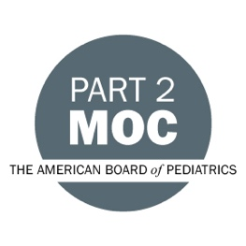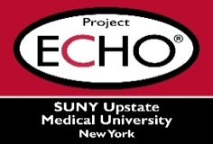**

**SUNY Upstate Project ECHO® (Extension for Community Healthcare Outcomes)**

**SUNY Upstate Primary Care Family Medicine TeleECHO**

***Emotional Intelligence and Conflict Resolution: Impact on Managing Team Dynamics.***

**SUNY Upstate**

**Syracuse, NY**

**Tuesday, March 5, 2024**

**12-1 PM**

**TARGET AUDIENCE:**Physicians, Physicians Assistants, Nurse Practitioners, Registered Nurses, Community Health Care Workers, Pre-Hospital Healthcare workers, Pharmacists, Emergency Care Providers, Preceptors

**PRESENTERS:**

Angela Wratney

**OBJECTIVES:**   
Participants will be able to:

* Define the principals of emotional intelligence.
* Review tactics to fuel your emotional intelligence factor.
* Applications of emotional intelligence to managing team dynamics.
* Understand why emotional intelligence is critical for conflict resolution.

**ACCREDITATION:** SUNY Upstate Medical University is accredited by the Accreditation Council for Continuing Medical Education (ACCME) to provide continuing education for physicians.

**CREDIT DESIGNATION**: SUNY Upstate Medical University designates this live activity for a maximum of 1.0 *AMA PRA Category 1 Credits™.* Physicians should claim only the credit commensurate with the extent of their participation in the activity.

**MOC:** Successful completion of this CME activity, which includes participation in the evaluation component, enables the participant to earn

-one MOC point in the American Board of Internal Medicine's (ABIM) Maintenance of Certification (MOC) program; and

-one MOC point in the American Board of Pediatrics’ (ABP) Maintenance of Certification (MOC) program.

It is the CME activity provider's responsibility to submit participant completion information to ACCME for the purpose of granting ABIM or ABP MOC credit.

**PLANNER DISCLOSURES**: A. Wratney and K. Donovan do not have relevant financial relationships with ineligible companies.

**SPEAKER DISCLOSURE**: A. Wratney, does not have any relevant financial relationships with ineligible companies.

**MITIGATION:** All listed relevant financial relationships have been mitigated.

**COMMERCIAL SUPPORT:** No commercial is received for this CME program.