1-Please use Google Chrome, no other browser will work

2-Verify the IX Drill Extension is there by clicking the puzzle piece in the top right of Google Chrome Browser

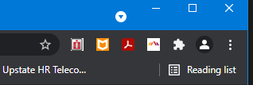

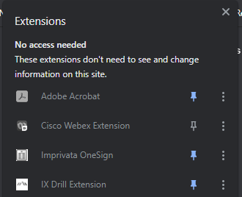

3-To the Right of IX Drill Extension Click the 3 dots and select Options
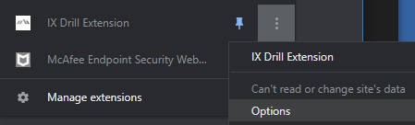

4-Verify this is entered below. Must have https
https://mhcexpress.upstate.edu/

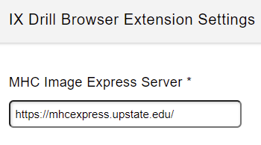

5-Click Save

6-CLOSE GOOGLE CHROME (all tabs)

7-Relaunch Google Chrome

8-Login to Lawson, once there is an item in your cart go to the Basic or Accounting tab

Here is a document explaining this:

Microsoft Word - Adding Documents in RQC.docx (upstate.edu)

