- In Chrome, click on the 3 dots top right, then click on Settings
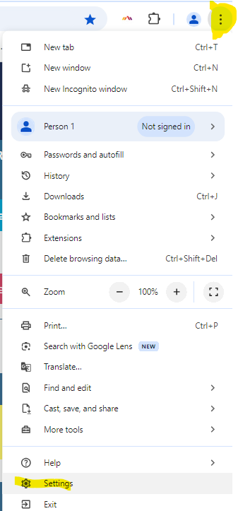

- In the left panel, click on Privacy and security, then click on right arrow in Delete browsing data
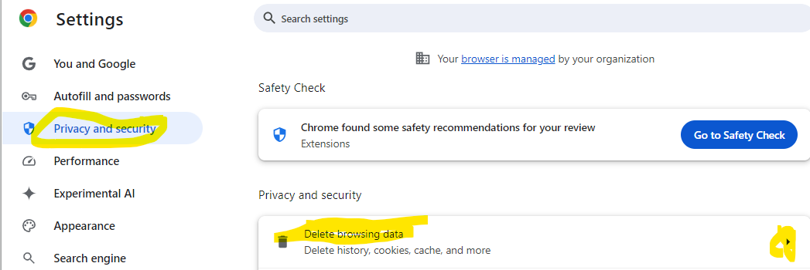

- Screen should look like below
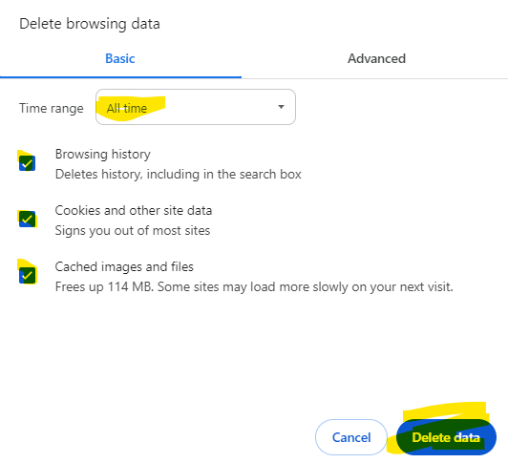

- Close the browser and open Chrome again.

