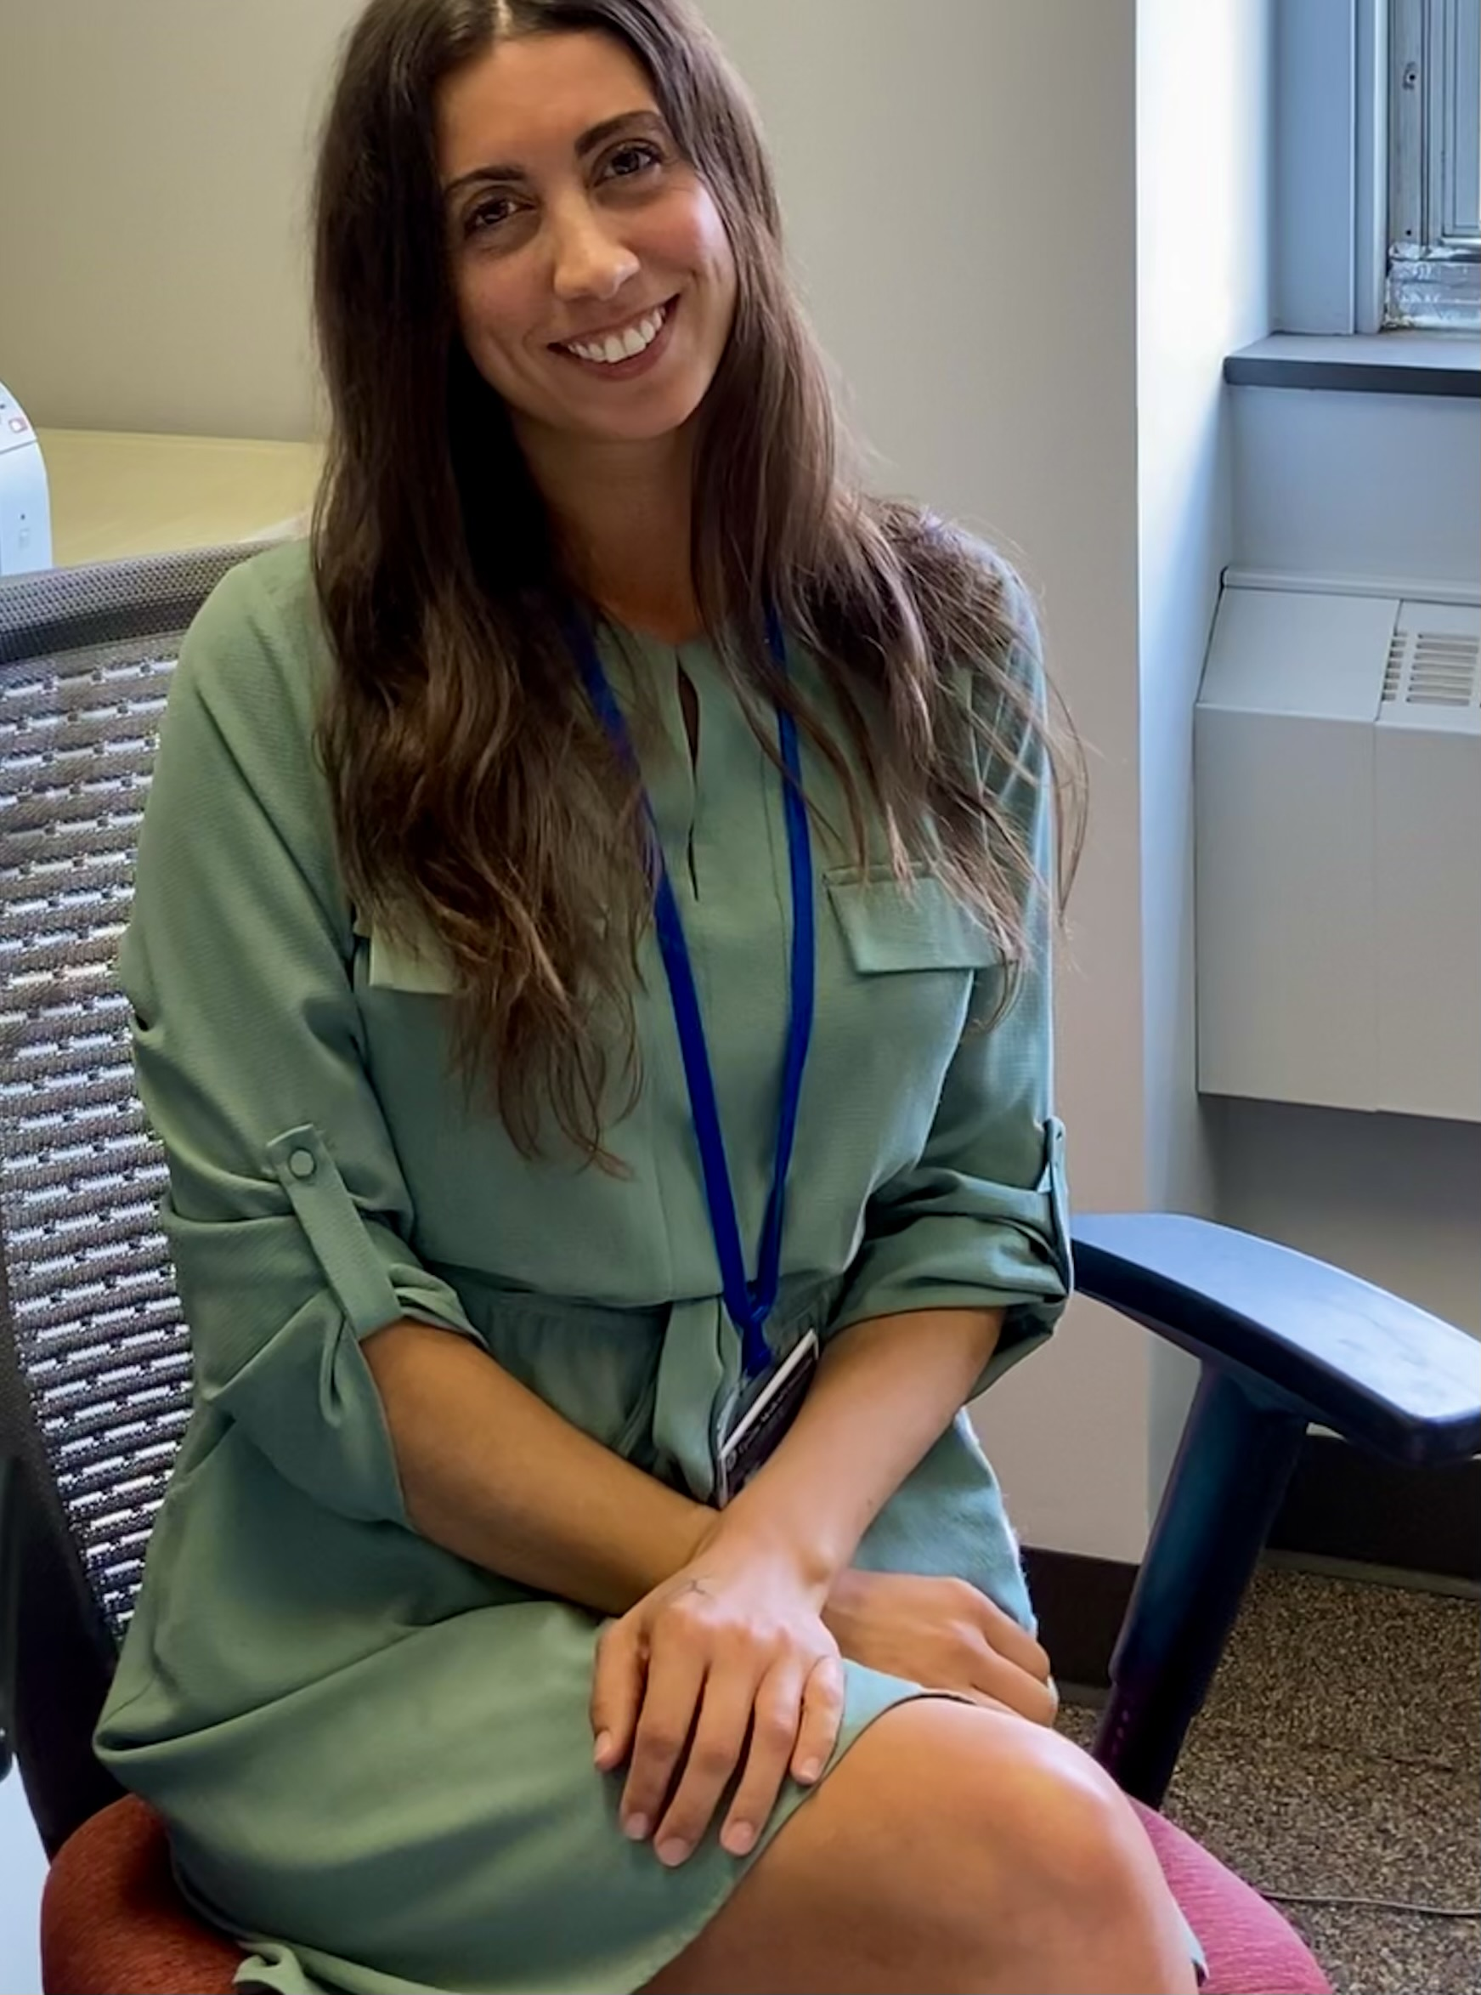
Andrea Rhea – Coordinator of Combined Programs and Special Initiatives
Rheaa@upstate.edu

Throughout my professional life, students have always inspired me. That is why I am excited to be able to introduce myself as your MD/PhD Program Coordinator!
In 2019, I moved back to Syracuse in order to be closer to family. I grew up in the area, attended college in Buffalo and was recruited by schools in Baltimore, Maryland to teach science. I have two children. Simon is four and he was born in Baltimore. Oscar is one (almost two) and he was born here in 2020. COVID unexpectedly kept me home with them. It was both a silver lining and a challenging time.
Officially, as an educator, I developed biology and chemistry curricula and delivered content. It wasn’t until I was assigned an advisory in 2015 that I was able to break-out of a traditional teaching role in order to meet a range of unique needs for my advisees. Student support and success became my focus and a lasting passion.
I have been fortunate to work alongside student-centered progressive educators and groundbreaking educational leaders in various settings. Working in a dynamic city has also provided me with the tools needed to support diverse groups of students. In 2019, I graduated my wonderful cohort of advisees. Today, they all possess the potential to make change and I enjoy keeping in touch with each of them.
Over the past year, when I was mostly home with my children, I co-founded a boutique recruiting firm which specialized in matching data science candidates to data-driven businesses. As one of the lead recruiters, I was able to guide candidates throughout the hiring process. This opportunity presented me with new and unexpected avenues for working alongside emerging young minds. There were many parallels between highly personalized recruitment and my former work with student advisement. Despite the excitement of a new business, I missed being in an academic setting.
I believe my array of experience has provided me with skills and insights required to effectively support you. I also intend to integrate what I’ve learned surrounding relationship cultivation and community building. In an increasingly atomized society obsessed with self-reliance, I believe a strong sense of community is more important than ever. I will be a reliant and physical presence for you throughout your program. Please feel free to visit and/or reach out!
I am thrilled to be your MD/PhD Program Coordinator and look forward to meeting each of you!

