MD/PhD Accepted Student Days

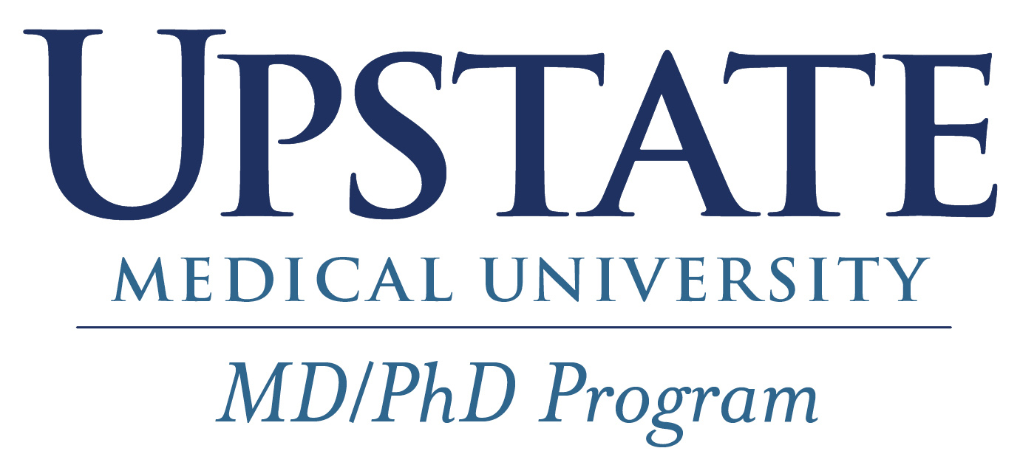

Hosted by the MD/PhD Program

Accepted Student Welcoming Committee

Andrea Cifonelli (cifonela@upstate.edu)

Matty Lesko (leskom@upstate.edu)

Jessica Crooker (crookerj@upstate.edu)

Dr. Amit Dhamoon (dhamoona@upstate.edu)

**Wednesday, February 28, 2024**

**Planning and *Arrival**

Connect with your student buddy prior for any question to arrange carpooling to campus/hotel, recommendations, etc.

Text/call your student buddy upon arrival

**Campus**: Weiskotten Hall, 766 Irving Ave, Syracuse, NY 13210

**Andrea’s Office** (can drop bags here): Weiskotten Hall, Room 3118

**Hotel**: Sheraton Syracuse University Hotel, 801 University Avenue, Syracuse 315-475-3000

*Check-in: 4PM - Call day of to inquire about early check-in. Feel free to drop off any bags in Andrea’s office when you arrive

**1:00PM – 2:00PM**

**Welcome Reception**

**Location: Weiskotten Hall 2231**

*Lunch provided (King David’s Restaurant)*

Speakers include the Accepted Student Welcoming Committee (Dr. Amit Dhamoon, Andrea Cifonelli, Jessica Crooker and Matty Lesko), Dr. Adam Waickman and Dr. Stewert Loh

**2:00PM – 3:00PM**

**Tour - Part 1**

**Location: Start from Welcome Reception > IHP > Back to Weiskotten**

Tour given by Matty Lesko and Jessica Crooker

**3:00PM – 4:00PM**

**Afternoon Tea with the College of Graduate Studies**

**Location: Weiskotten 3122**

This is a weekly social event in the college. You will meet the Dean of Graduate Studies (Dr. Mark Schmitt), the Assistant Dean of Graduate Studies (Dr. Steven Taffet), and various members of the graduate department including staff, students and postdocs. Members from labs of interest will be highly encouraged to attend.

**4:00PM – 6:00PM**

**Hotel Check-in**

**Location: Sheraton Syracuse University Hotel, 801 University Ave**

Take time to settle in. Feel free to grab a coffee/tea/snack near the hotel toward Marshall Street.

**6:00PM – 8:00PM**

**Dinner, Meet and Mingle + Games**

**Location: Jessica’s House (1143 Cumberland Ave, Syracuse, NY 13210)**

*Dinner provided (Dosa Grill)*

For carpooling purposes, please discuss with your student buddy or other visiting candidates about attending this event. Jessica is a homeowner in a nearby neighborhood off-campus.

**Thursday, February 29, 2024**

**9:00AM – 10:00AM**

**Breakfast**

**Location: Setnor 3507/8**

*Breakfast provided (Dewitt Bagel Company)*

Feel free to use this location as a convenient meeting place for any faculty members whom you are planning to meet with. In the past, candidates have arranged meetings with faculty and the faculty member or someone from the lab met and escorted the candidate to the lab for a visit. There is time afterwards for multiple meetings and lab visits. Please plan accordingly.

**10:00AM – 12:00PM**

**Free Time**

We encourage you to use this time to meet with potential research mentors. It is appropriate to request an escort from the faculty member or lab member to your next meeting, if needed. Please plan accordingly.

Alternatively, you can take time to explore the areas and grab a coffee and/or bite to eat. Reach out to your student buddy for recommendations and use our recommendation list below this agenda.

**12:00PM – 1:30PM**

**Tour- Part 2**

**Location: Start in Weiskotten 3120 (next to Andrea’s office) > Chen Lab > NAB > Hospital > Cancer Center > Nappi Wellness > CAB > Crouse > Weiskotten**

Lunch is *not* provided today. Please plan accordingly.

**1:30PM – 4:30PM**

**Free Time**

We encourage you to use this time to meet with potential research mentors. It is appropriate to request an escort from the faculty member or lab member to your next meeting, if needed. Please plan accordingly.

Alternatively, you can take time to explore the areas and grab a coffee and/or bite to eat. Please text your student buddy if you need some recommendations on the spot and see the list below this agenda.

**4:30PM – 6:00PM**

**Grand Rounds**

**Location: NAB 4414A**

*Dinner provided (Change of Pace)*

**7:00PM**

**Happy Hour**

Location: Salt City Market

**Friday, March 1, 2024**

Check-out

You can plan meetings with potential research mentors on this date, if needed.

Recommendations

We encourage you to explore Syracuse and we would be happy to help you plan your stay outside of the Accepted Student Day itinerary. Let us know what you might be interested in!

|  |
| --- |
| Food and Coffee |
| Marshall Street – SUNY Upstate/Syracuse University food district   * *Poke Bowl * *Varsity * *Bleu Monkey Cafe * *Chipotle * *Salt City Coffee * *Purple Banana   University Hill – Syracuse University, SUNY Upstate Medical University, and SUNY Environmental Science and Forestry (ESF)   * *Brazen Cafe * *Strong Hearts (vegan) * *Heritage Cafe * *Phoebe’s * *XO Taco   Westcott – Charming, eclectic “village” that backs up to Thornden Park   * Recess Coffee * Alto Cinco * Rise n' Shine Cafe   Armory Square/Downtown - Primary “downtown” district   * Salt City Market * Oh My Darling * Pastabilities * LM Social * Cake Bar * Apizza Regionale * The York * Dinosaur BBQ   Hanover Square – Historic, original market square downtown   * The Fish Friar * The Evergreen   Eerie Boulevard and Surrounding Areas   * KPot (Korean BBQ) * Sake Bomb * Red Chilis (hot pot and the soup dumplings)   *walking distance |

|  |
| --- |
| Getting Outside |
| * Onondaga Creekwalk (running, walking, biking) * Thornden Park (large hilltop park) * Barry Park (park with running trail and sports fields) * [Clinton Square Ice Rink](https://www.syr.gov/clintonsquareicerink) * Onondaga Park (skate park, running, walking, biking) * Clark Reservation (hiking) * Four Seasons Golf and Ski Center (tubing, small hill skiing/snowboarding) * Labrador Mountain (skiing/snowboarding) * Song Mountain (skiing/snowboarding) * Greek Peak (skiing/snowboarding) |

|  |
| --- |
| Drinks and Entertainment |
| Bars and Indoor Live Music   * Al's Wine and Whiskey Lounge (live music + pool) * The Gilded Club * The Hops Spot (craft beers and bar games) * Funk n' Waffles (live music) * The York * LM Social * Salt City Market * Lemon Grass Restaurant (piano bar on Fridays) * Singers Karaoke Club   Desitny USA   * Funny Bones (comedy club) * Escape Room ([Mystery Room)](https://mysteryroom.com/locations/syracuse-ny/?gclid=CjwKCAiAzKqdBhAnEiwAePEjkiSXGUOYV3woVDVgIUiBCUZJE87wafmaN5T04Nm9u2rpHRPQclU1AxoCOLcQAvD_BwE)   Sports, Games and Shows   * Trivia ([Syracuse Trivia](https://syracusetrivianight.com/)) * Central Rock Gym (rock climbing) * JMA Wireless Dome (SU basketball games + concerts) * Syracuse Crunch (hockey) * The OnCenter (live shows and entertainment) * Turning Stone Casino (large casino, spa, dining, entertainment)   Casinos and Spa   * Turning Stone Casino (large casino, spa, dining, entertainment) * Yellow Brick Road (small casino, dining, bowling and screen golf) |