**PICU Shared Governance Fundraiser**

Please help support the Pediatric ICU Shared Governance Team!

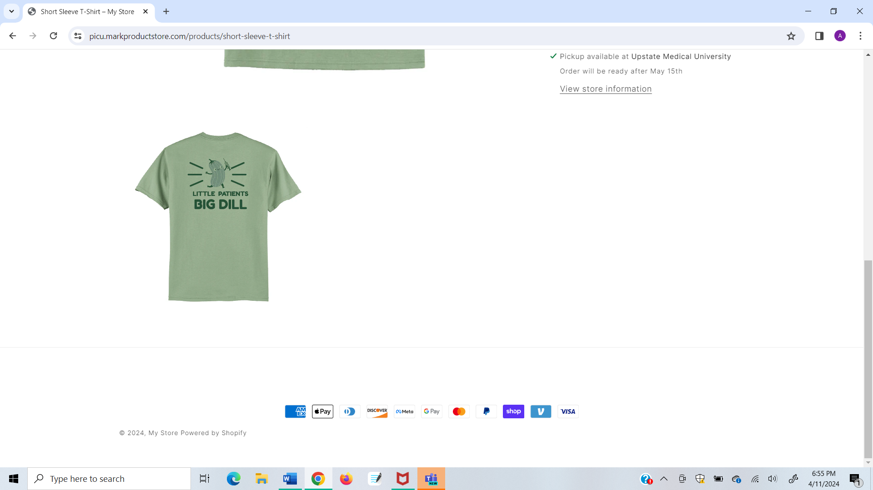Short-sleeve T-shirt $20

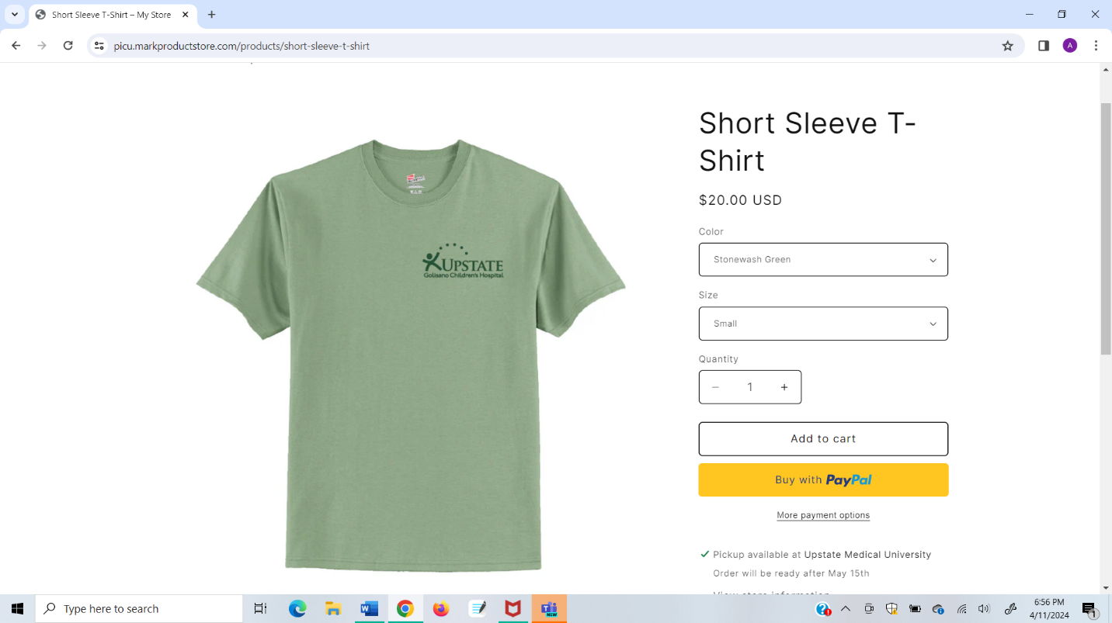

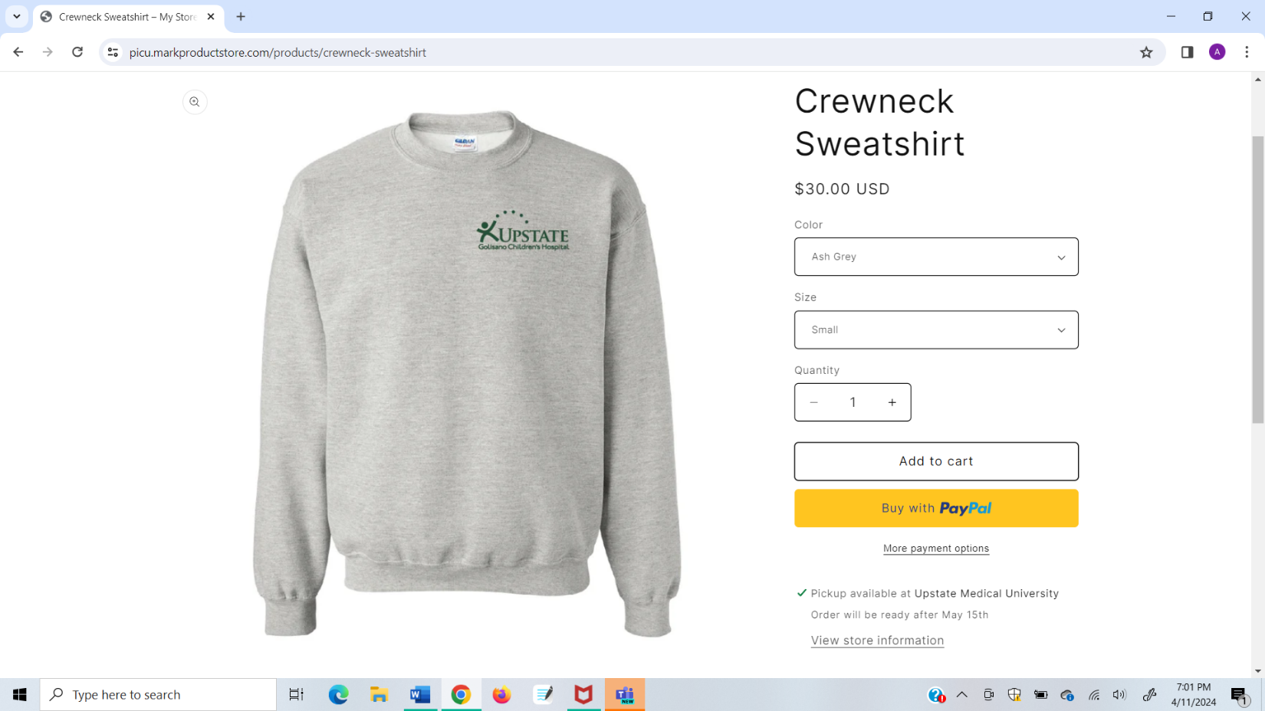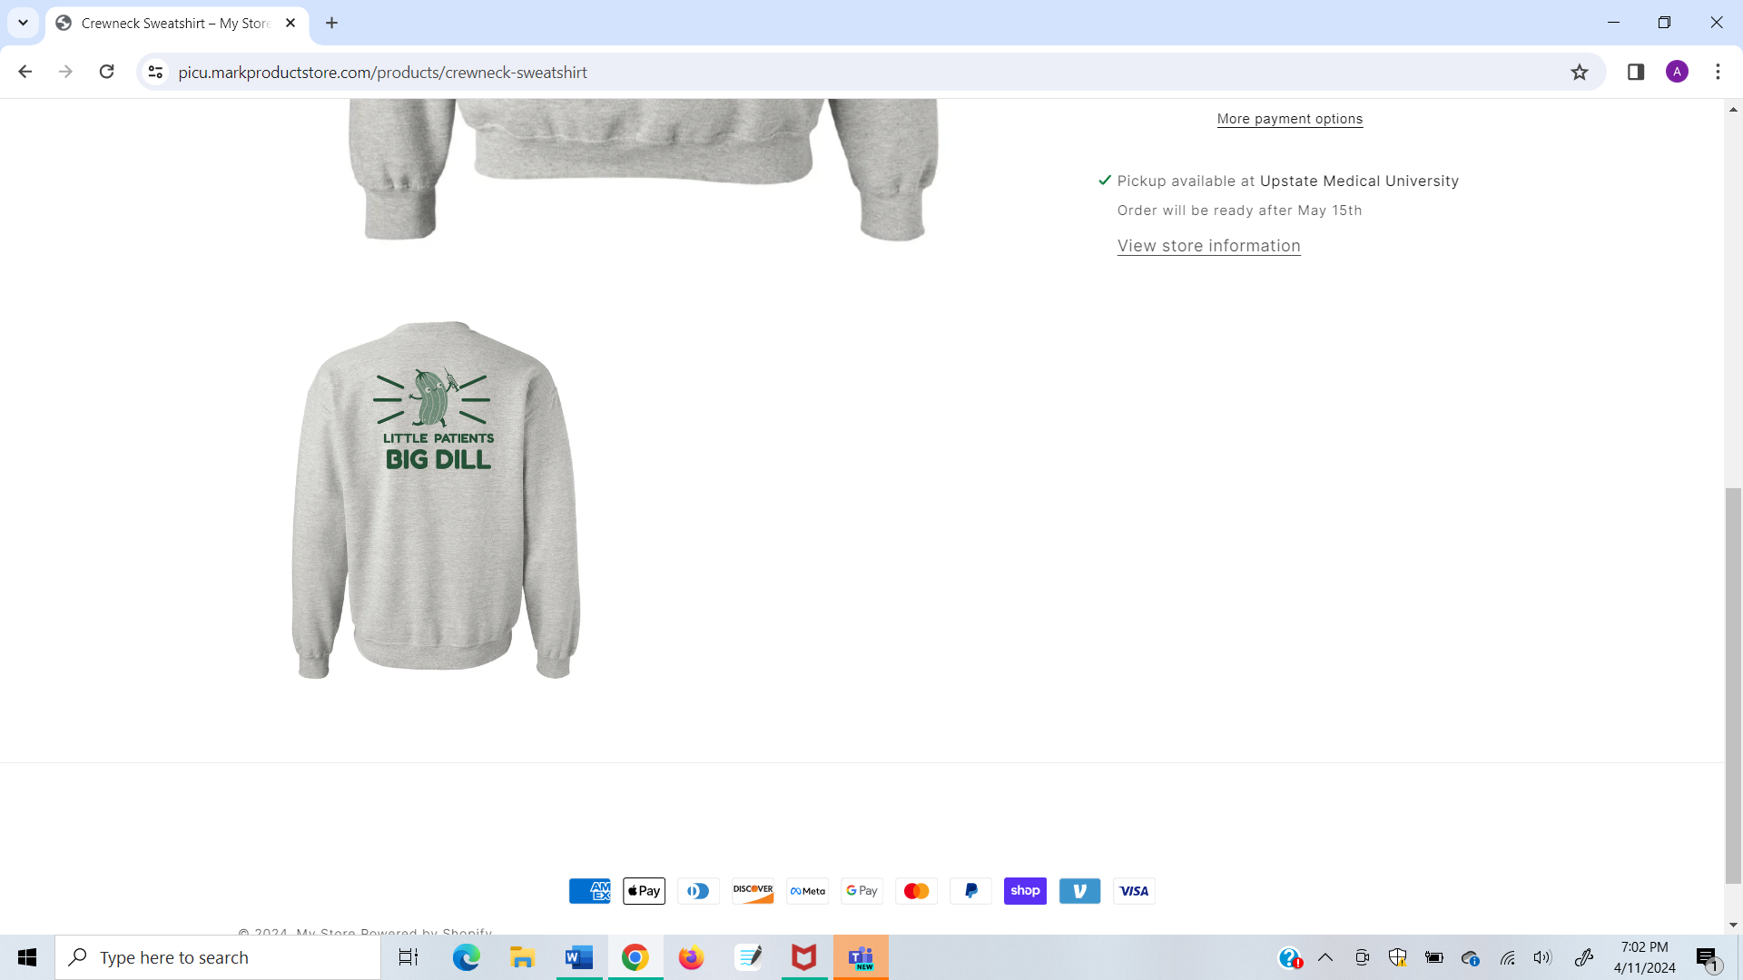Crewneck Sweatshirt $30

Scan the QR code to purchase from our online store – ordering is open until May 1st

**PICKUP:** on 12F after May 15th, you will receive an email with pickup times from Angie and Emily

**Questions? Contact Angie White or Emily McMahon**