**OCTOBER IS DOMESTIC VIOLENCE AWARENESS MONTH**

**UPSTATE “Keep Growing” SHIRT SALE**

**PROCEEDS WILL BENEFIT THE UPSTATE FOUNDATION SOCIAL WORK FUND**

Here is the link to the store or use the QR Code below: [https://upstatedv.myshopify.com/](https://urldefense.com/v3/__https:/upstatedv.myshopify.com/__;!!GobTDDpD7A!NOhd4Zj9fyA0Y8RPLDq9p7IG4A8IjeDFFS11HPxRSeocloz7Q3Ba_zXqX6oFNnczCXzJSrJ6v7qesc5W968dMw$)

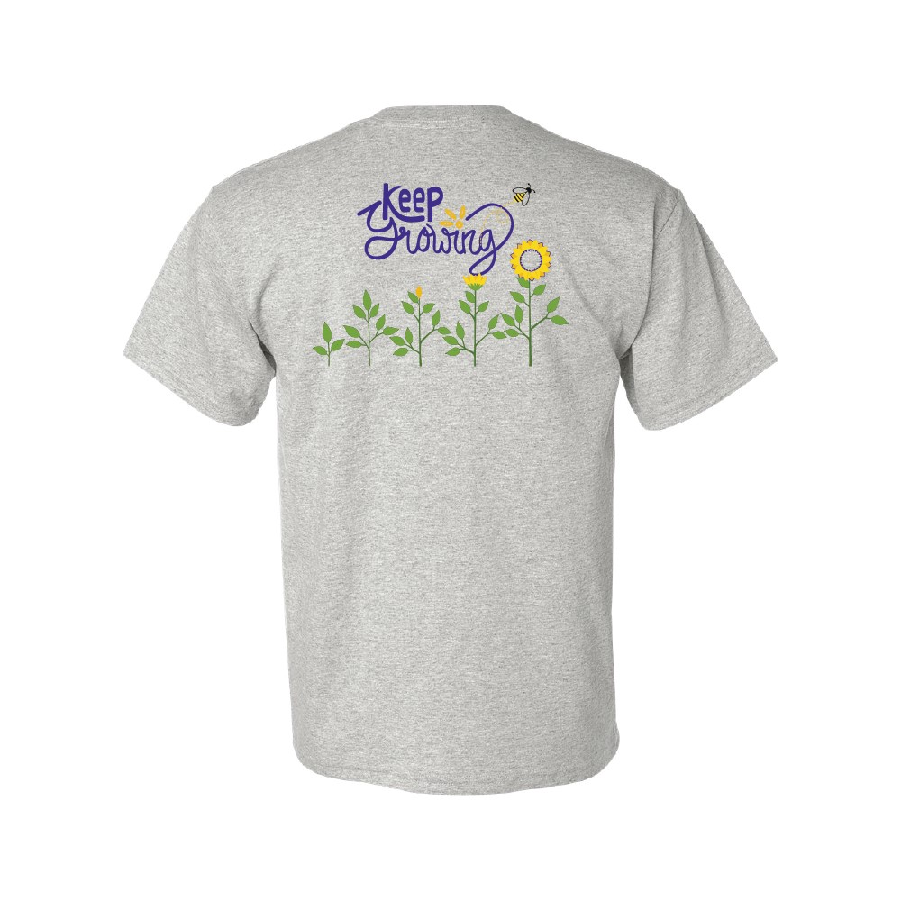 

**BACK**

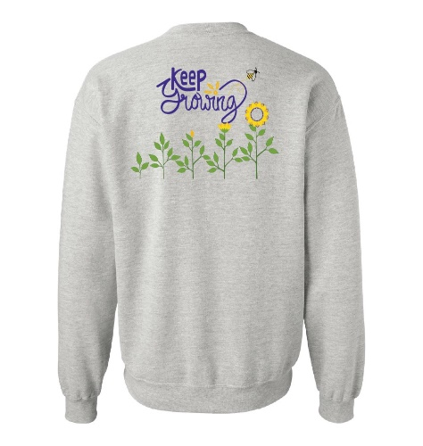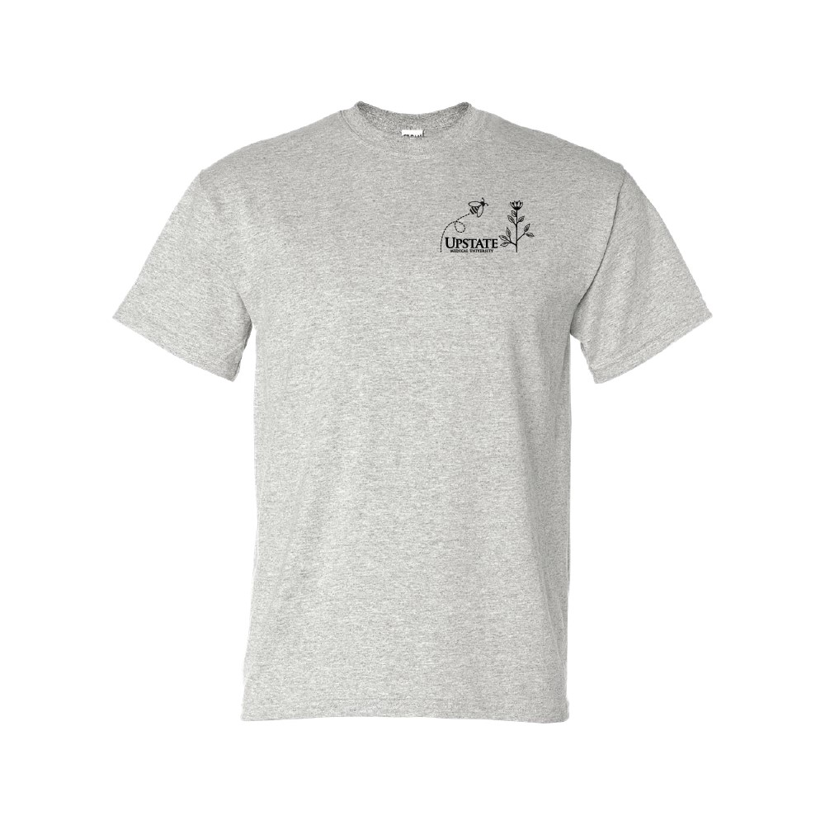

**FRONT**

**Order Closes: Friday 11/8**

**\*APPAREL ORDERS WILL BE PICKED UP & DELIVERED TO EACH CAMPUS\***

**Apparel Store Coordinator:**Allison Roberts, Social Work

[roberall@upstate.edu](mailto:roberall@upstate.edu) 492-3242