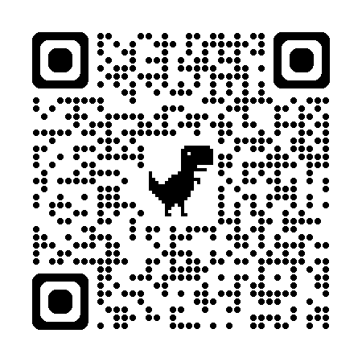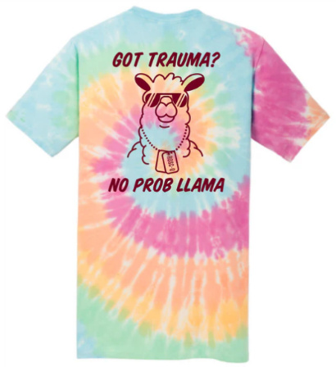**PICU Shared Governance Fundraiser Sale**

T-SHIRTS $20

CREWNECK SWEATSHIRTS $30

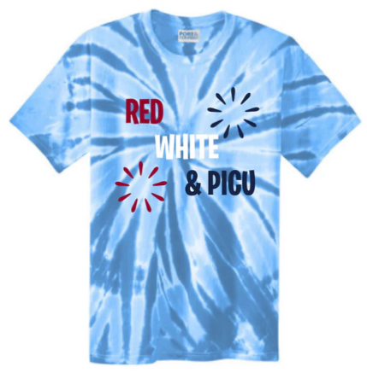

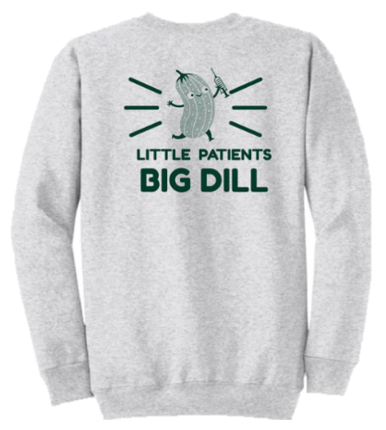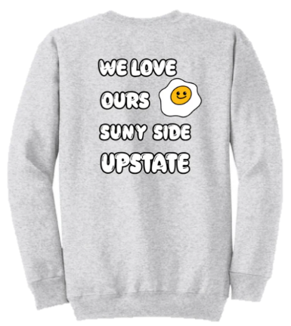

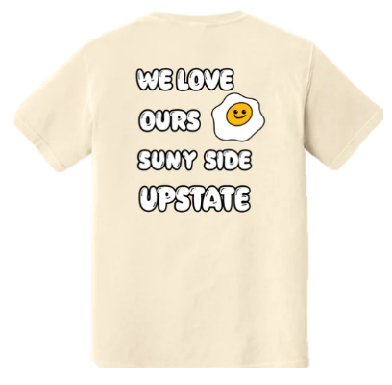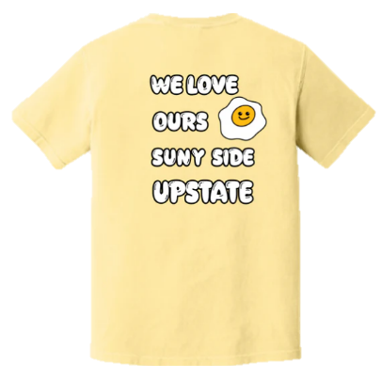

Use the QR code above or <https://upstatepicu.myshopify.com/> for access – the sale will be live **until 5/25**, items can be expected approximately 2 weeks following the end of sale.

Shipping options are available at an additional cost, otherwise you will receive an email with pick up instructions after products have arrived. If you are ordering from outside of the downtown campus, we suggest a group order with shipping for easier delivery.

Please enter an email that you check regularly and save your order number for contact with pickup dates and location (downtown campus).

We appreciate your support!

Questions? Contact Angie White, whiteang@upstate.edu!