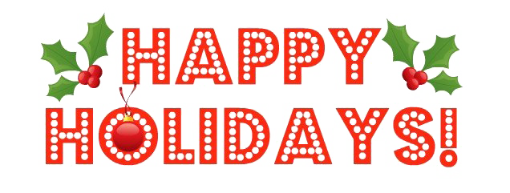
Nursing Excellence System Council’s
Nursing Unit’s Holiday Card Contest
Get into the holiday spirit & showcase your unit’s creativity!
Contest Deadline: December 1st
Prize: Coffee, Hot Cocoa & Cookies
Winner Announcement: December 5th
Join the fun and spread some cheer by creating a festive holiday card that reflects your unit’s teamwork, compassion, & creativity!
Use the QR code below to submit!
