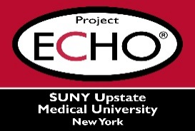

**SUNY Upstate Project ECHO® (Extension for Community Healthcare Outcomes)**

**SUNY Upstate Emergency Medicine TeleECHO**

**Burn – Cold-Related Injuries**

**SUNY Upstate**

**Syracuse, NY**

**Tuesday, August 2, 2023**

**12-1 PM**

**TARGET AUDIENCE:**Physicians, Physicians Assistants, Nurse Practitioners, Registered Nurses, Community Health Care Workers, Pre-Hospital Healthcare workers, Pharmacists, Emergency Care Providers

**PRESENTER:**   
Alex Helkin, MD, FACS

**OBJECTIVES:**   
Participants will be able to:

* Recognize risks factors for and types of cold-related injuries.
* Differentiate between systematic and localized cold injuries.
* Understand treatment options based on pathophysiology and grade.

**ACCREDITATION:** SUNY Upstate Medical University is accredited by the Accreditation Council for Continuing Medical Education (ACCME) to provide continuing education for physicians.

**CREDIT DESIGNATION**: SUNY Upstate Medical University designates this live activity for a maximum of 1.0 *AMA PRA Category 1 Credits™.* Physicians should claim only the credit commensurate with the extent of their participation in the activity.

**PLANNER DISCLOSURES**: None of the planners have relevant financial relationships with ineligible companies.

**SPEAKER DISCLOSURE**: A. Helkin does not have relevant financial relationships with ineligible companies.

**COMMERCIAL SUPPORT:** No commercial is received for this CME program.