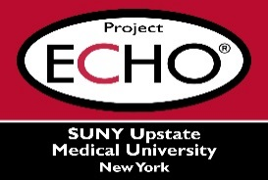

**SUNY Upstate Project ECHO® (Extension for Community Healthcare Outcomes)**

**SUNY Upstate Emergency Medicine TeleECHO**

**REACH – Medication for Opioid Use Disorder in the Primary Care Setting**

**SUNY Upstate**

**Syracuse, NY**

**Wednesday, October 22, 2025**

**12-1 PM**

**TARGET AUDIENCE:**Physicians, Physicians Assistants, Nurse Practitioners, Registered Nurses, Community Health Care Workers, Pre-Hospital Healthcare workers, Pharmacists, Emergency Care Providers

**PRESENTER:**   
Tolani Ajagbe, MBBS

**OBJECTIVES:**   
Participants will be able to:

* Define opioid use disorder and explore common risk factors for opioid addiction.
* Discuss the three FDA approved medications for treatment of opioid use disorder, and their feasibility in the primary care setting.

**ACCREDITATION:** SUNY Upstate Medical University is accredited by the Accreditation Council for Continuing Medical Education (ACCME) to provide continuing education for physicians.

**CREDIT DESIGNATION**: SUNY Upstate Medical University designates this live activity for a maximum of 1.0 *AMA PRA Category 1 Credits™.* Physicians should claim only the credit commensurate with the extent of their participation in the activity.

**PLANNER DISCLOSURES**: None of the planners have relevant financial relationships with ineligible companies.

**SPEAKER DISCLOSURE**: T. Ajagbe does not have relevant financial relationships with ineligible companies.

**COMMERCIAL SUPPORT:** No commercial is received for this CME program.