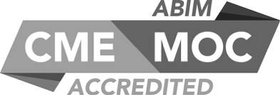

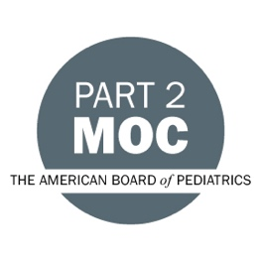
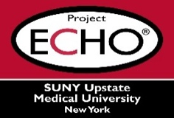

SUNY Upstate Project ECHO® (Extension for Community Healthcare Outcomes)
SUNY Upstate Toxicology TeleECHO
TikTok and Poison Centers: Do they Intersect?
SUNY Upstate
Syracuse, NY
Tuesday, November 21, 2023
Noon - 1 PM
TARGET AUDIENCE:
Physicians, Physicians Assistants, Nurse Practitioners, Registered Nurses, Community Health Care Workers, Pre-Hospital Healthcare workers, Pharmacists, Emergency Care Providers, Preceptors

PRESENTERS:
Jeanna Marraffa, PHARMD, MPH, DABAT, FAACT

OBJECTIVES:
- Describe how recent social media trends have resulted in poisoning cases.
- Discuss the potential dangers of social media trends.
- Discuss how the poison center can be a resource as emerging trends occur.

ACCREDITATION: SUNY Upstate Medical University is accredited by the Accreditation Council for Continuing Medical Education (ACCME) to provide continuing education for physicians.
CREDIT DESIGNATION: SUNY Upstate Medical University designates this live activity for a maximum of 1.0 AMA PRA Category 1 Credits™. Physicians should claim only the credit commensurate with the extent of their participation in the activity.
PLANNER DISCLOSURES: J. Marraffa, K. Donovan do not have relevant financial relationships with ineligible companies.
SPEAKER DISCLOSURE: J. Marraffa does not have relevant financial relationships with ineligible companies.
MITIGATION: All listed relevant financial relationships have been mitigated.
COMMERCIAL SUPPORT: No commercial is received for this CME program.

