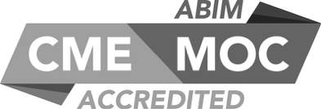

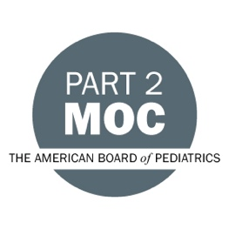
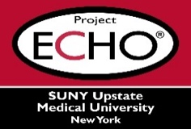

SUNY Upstate Project ECHO® (Extension for Community Healthcare Outcomes)
SUNY Upstate Primary Care Family Medicine TeleECHO
AI in Medicine: Exploring Applications Across Clinical Care, Medical Education, Operations, and Research
SUNY Upstate
Syracuse, NY
Monday, February 24, 2025
12-1 PM
TARGET AUDIENCE:
Physicians, Physicians Assistants, Nurse Practitioners, Registered Nurses, Community Health Care Workers, Pre-Hospital Healthcare workers, Pharmacists, Emergency Care Providers, Preceptors

PRESENTERS:
Margaret Ann Smith, MBA
Betsy Yang, MD, MPH

OBJECTIVES:
Participants will be able to:
- Understand the basics of machine learning and generative AI.
- Identify ways AI is being used in multiple healthcare domains.
- Discuss practical examples of AI applications in multiple healthcare domains.

ACCREDITATION: SUNY Upstate Medical University is accredited by the Accreditation Council for Continuing Medical Education (ACCME) to provide continuing education for physicians.
CREDIT DESIGNATION: SUNY Upstate Medical University designates this live activity for a maximum of 1.0 AMA PRA Category 1 Credits™. Physicians should claim only the credit commensurate with the extent of their participation in the activity.
MOC: Successful completion of this CME activity, which includes participation in the evaluation component, enables the participant to earn
-one MOC point in the American Board of Internal Medicine's (ABIM) Maintenance of Certification (MOC) program; and
-one MOC point in the American Board of Pediatrics’ (ABP) Maintenance of Certification (MOC) program.
It is the CME activity provider's responsibility to submit participant completion information to ACCME for the purpose of granting ABIM or ABP MOC credit.
PLANNER DISCLOSURES: K. Donovan, A. Botash, M. Mason, J. Young do not have relevant financial relationships with ineligible companies.
SPEAKER DISCLOSURE: M. Smith and B. Yang do not have any relevant financial relationships with ineligible companies.
MITIGATION: All listed relevant financial relationships have been mitigated.
COMMERCIAL SUPPORT: No commercial is received for this CME program.

