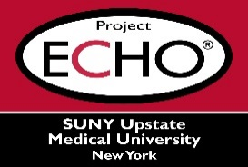


SUNY Upstate Project ECHO® (Extension for Community Healthcare Outcomes)

SUNY Upstate Emergency Medicine TeleECHO
REACH – The Addicted Brain: How is it Different?
SUNY Upstate
Syracuse, NY
Wednesday, September 17, 2025
12-1 PM

TARGET AUDIENCE:
Physicians, Physicians Assistants, Nurse Practitioners, Registered Nurses, Community Health Care Workers, Pre-Hospital Healthcare workers, Pharmacists, Emergency Care Providers

PRESENTER:
Thomas Schwartz, MD

OBJECTIVES:
Participants will be able to:
- Participant will be able to describe normal brain functioning.
- Participant will be able to describe how addiction changes brain functioning.

ACCREDITATION: SUNY Upstate Medical University is accredited by the Accreditation Council for Continuing Medical Education (ACCME) to provide continuing education for physicians.

CREDIT DESIGNATION: SUNY Upstate Medical University designates this live activity for a maximum of 1.0 AMA PRA Category 1 Credits™. Physicians should claim only the credit commensurate with the extent of their participation in the activity.

PLANNER DISCLOSURES: None of the planners have relevant financial relationships with ineligible companies.
SPEAKER DISCLOSURE: T. Schwartz has relevant financial relationships with ineligible companies.
MITIGATION: All financial relationships have been mitigated.
COMMERCIAL SUPPORT: No commercial is received for this CME program.

