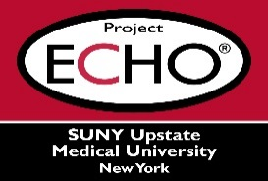


SUNY Upstate Project ECHO® (Extension for Community Healthcare Outcomes)

SUNY Upstate Emergency Medicine TeleECHO
REACH – Smoking Cessation in Primary Care Practice
SUNY Upstate
Syracuse, NY
Wednesday, September 24, 2025
12-1 PM

TARGET AUDIENCE:
Physicians, Physicians Assistants, Nurse Practitioners, Registered Nurses, Community Health Care Workers, Pre-Hospital Healthcare workers, Pharmacists, Emergency Care Providers

PRESENTER:
Zsuzsa Szombathyne Meszaros, MD, PhD, DFAPA

OBJECTIVES:
Participants will be able to:
- Review DSM-5TR criteria of nicotine use disorder.
- Identify FDA approved medications for smoking cessation.
- Discuss the role of motivational interviewing in treatment of individuals with nicotine use disorder.

ACCREDITATION: SUNY Upstate Medical University is accredited by the Accreditation Council for Continuing Medical Education (ACCME) to provide continuing education for physicians.

CREDIT DESIGNATION: SUNY Upstate Medical University designates this live activity for a maximum of 1.0 AMA PRA Category 1 Credits™. Physicians should claim only the credit commensurate with the extent of their participation in the activity.

PLANNER DISCLOSURES: None of the planners have relevant financial relationships with ineligible companies.
SPEAKER DISCLOSURE: Z. S. Meszaros does not have relevant financial relationships with ineligible companies.
COMMERCIAL SUPPORT: No commercial is received for this CME program.

