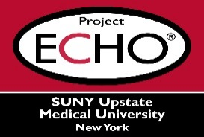


SUNY Upstate Project ECHO® (Extension for Community Healthcare Outcomes)

SUNY Upstate Emergency Medicine TeleECHO
Burn – Cold-Related Injuries
SUNY Upstate
Syracuse, NY
Tuesday, August 2, 2023
12-1 PM

TARGET AUDIENCE:
Physicians, Physicians Assistants, Nurse Practitioners, Registered Nurses, Community Health Care Workers, Pre-Hospital Healthcare workers, Pharmacists, Emergency Care Providers

PRESENTER:
Alex Helkin, MD, FACS

OBJECTIVES:
Participants will be able to:
- Recognize risks factors for and types of cold-related injuries.
- Differentiate between systematic and localized cold injuries.
- Understand treatment options based on pathophysiology and grade.

ACCREDITATION: SUNY Upstate Medical University is accredited by the Accreditation Council for Continuing Medical Education (ACCME) to provide continuing education for physicians.

CREDIT DESIGNATION: SUNY Upstate Medical University designates this live activity for a maximum of 1.0 AMA PRA Category 1 Credits™. Physicians should claim only the credit commensurate with the extent of their participation in the activity.

PLANNER DISCLOSURES: None of the planners have relevant financial relationships with ineligible companies.
SPEAKER DISCLOSURE: A. Helkin does not have relevant financial relationships with ineligible companies.
COMMERCIAL SUPPORT: No commercial is received for this CME program.

