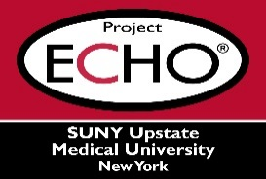


SUNY Upstate Project ECHO® (Extension for Community Healthcare Outcomes)

SUNY Upstate Emergency Medicine TeleECHO
REACH – Medication for Opioid Use Disorder in the Primary Care Setting
SUNY Upstate
Syracuse, NY
Wednesday, October 22, 2025
12-1 PM

TARGET AUDIENCE:
Physicians, Physicians Assistants, Nurse Practitioners, Registered Nurses, Community Health Care Workers, Pre-Hospital Healthcare workers, Pharmacists, Emergency Care Providers

PRESENTER:
Tolani Ajagbe, MBBS

OBJECTIVES:
Participants will be able to:
- Define opioid use disorder and explore common risk factors for opioid addiction.
- Discuss the three FDA approved medications for treatment of opioid use disorder, and their feasibility in the primary care setting.

ACCREDITATION: SUNY Upstate Medical University is accredited by the Accreditation Council for Continuing Medical Education (ACCME) to provide continuing education for physicians.
CREDIT DESIGNATION: SUNY Upstate Medical University designates this live activity for a maximum of 1.0 AMA PRA Category 1 Credits™. Physicians should claim only the credit commensurate with the extent of their participation in the activity.
PLANNER DISCLOSURES: None of the planners have relevant financial relationships with ineligible companies.
SPEAKER DISCLOSURE: T. Ajagbe does not have relevant financial relationships with ineligible companies.
COMMERCIAL SUPPORT: No commercial is received for this CME program.

