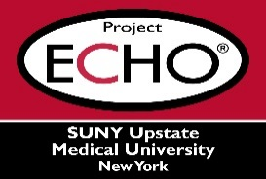


SUNY Upstate Project ECHO® (Extension for Community Healthcare Outcomes)

SUNY Upstate Emergency Medicine TeleECHO
REACH – Substance Use Disorders in Perinatal Population
SUNY Upstate
Syracuse, NY
Wednesday, October 29, 2025
12-1 PM

TARGET AUDIENCE:
Physicians, Physicians Assistants, Nurse Practitioners, Registered Nurses, Community Health Care Workers, Pre-Hospital Healthcare workers, Pharmacists, Emergency Care Providers

PRESENTER:
Tolani Ajagbe, MBBS
Nevena Radonjic, MD/PhD

OBJECTIVES:
Participants will be able to:
- Review impact of substance use disorders in perinatal population on mother and infant.
- Discuss systematic screening, evaluation and methods to manage substance use disorders in perinatal period.
- Review the role of Project TEACH in supporting primary providers treating perinatal patients with mental health conditions

ACCREDITATION: SUNY Upstate Medical University is accredited by the Accreditation Council for Continuing Medical Education (ACCME) to provide continuing education for physicians.
CREDIT DESIGNATION: SUNY Upstate Medical University designates this live activity for a maximum of 1.0 AMA PRA Category 1 Credits™. Physicians should claim only the credit commensurate with the extent of their participation in the activity.
PLANNER DISCLOSURES: None of the planners have relevant financial relationships with ineligible companies.
SPEAKER DISCLOSURE: T. Ajagbe and N. Radonjic does not have relevant financial relationships with ineligible companies.
COMMERCIAL SUPPORT: No commercial is received for this CME program.

