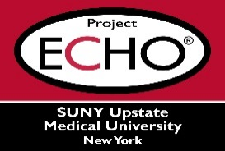


SUNY Upstate Project ECHO® (Extension for Community Healthcare Outcomes)

SUNY Upstate Emergency Medicine TeleECHO
Burn – The Toxic Gases in Fire A.K.A. The Toxic Twins
SUNY Upstate
Syracuse, NY
Tuesday, November 18, 2025
12-1 PM

TARGET AUDIENCE:
Physicians, Physicians Assistants, Nurse Practitioners, Registered Nurses, Community Health Care Workers, Pre-Hospital Healthcare workers, Pharmacists, Emergency Care Providers

PRESENTER:
Joan Dolinak, MD

OBJECTIVES:
Participants will be able to:
- Identify main chemicals in smoke which cause injury.
- Discuss treatment
- Discuss special circumstance with Lithium batteries.

ACCREDITATION: SUNY Upstate Medical University is accredited by the Accreditation Council for Continuing Medical Education (ACCME) to provide continuing education for physicians.

CREDIT DESIGNATION: SUNY Upstate Medical University designates this live activity for a maximum of 1.0 AMA PRA Category 1 Credits™. Physicians should claim only the credit commensurate with the extent of their participation in the activity.

PLANNER DISCLOSURES: None of the planners have relevant financial relationships with ineligible companies.
SPEAKER DISCLOSURE: J. Dolinak does not have relevant financial relationships with ineligible companies.
COMMERCIAL SUPPORT: No commercial is received for this CME program.

