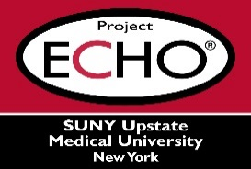


SUNY Upstate Project ECHO® (Extension for Community Healthcare Outcomes)

SUNY Upstate Emergency Medicine TeleECHO
REACH – Find Help Find Hope
SUNY Upstate
Syracuse, NY
Wednesday, November 19, 2025
12-1 PM

TARGET AUDIENCE:
Physicians, Physicians Assistants, Nurse Practitioners, Registered Nurses, Community Health Care Workers, Pre-Hospital Healthcare workers, Pharmacists, Emergency Care Providers

PRESENTER:
Joseph Ridgway
Linda Lazzari

OBJECTIVES:
Participants will be able to:
- Review the role of NAMI Syracuse and identify the education, services and advocacy provided by NAMI to our community
- Discuss the importance of recognizing mental health symptoms in everyday practice and access to available resources
- Summarize available classes and groups offered by NAMI Syracuse to help families of loved ones and individuals with coping tools and skills

ACCREDITATION: SUNY Upstate Medical University is accredited by the Accreditation Council for Continuing Medical Education (ACCME) to provide continuing education for physicians.
CREDIT DESIGNATION: SUNY Upstate Medical University designates this live activity for a maximum of 1.0 AMA PRA Category 1 Credits™. Physicians should claim only the credit commensurate with the extent of their participation in the activity.
PLANNER DISCLOSURES: None of the planners have relevant financial relationships with ineligible companies.
SPEAKER DISCLOSURE: J. Ridgway and L. Lazzari do not have relevant financial relationships with ineligible companies.
COMMERCIAL SUPPORT: No commercial is received for this CME program.

