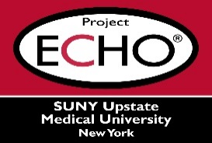


SUNY Upstate Project ECHO® (Extension for Community Healthcare Outcomes)

SUNY Upstate Emergency Medicine TeleECHO
“To Give or Not to Give” Cyano Kits, that is the Question
SUNY Upstate
Syracuse, NY
Tuesday, June 16th, 2026
12-1 PM

TARGET AUDIENCE:
Physicians, Physicians Assistants, Nurse Practitioners, Registered Nurses, Community Health Care Workers, Pre-Hospital Healthcare workers, Pharmacists, Emergency Care Providers

PRESENTER:
Joan Dolinak, MD

OBJECTIVES:
Participants will be able to:
- Describe how cyanokit works
- Describe best indications for cyanokit
- Describe pitfalls that can occur

ACCREDITATION: SUNY Upstate Medical University is accredited by the Accreditation Council for Continuing Medical Education (ACCME) to provide continuing education for physicians.

CREDIT DESIGNATION: SUNY Upstate Medical University designates this live activity for a maximum of 1.0 AMA PRA Category 1 Credits™. Physicians should claim only the credit commensurate with the extent of their participation in the activity.

PLANNER DISCLOSURES: None of the planners have relevant financial relationships with ineligible companies.
SPEAKER DISCLOSURE: R. Roberts does not have relevant financial relationships with ineligible companies.
COMMERCIAL SUPPORT: No commercial is received for this CME program.

