Toxicology Case Conference

February 22, 2024

Location: 9th Floor Conference Room/Zoom

Time: 1:30-3:30 PM

Leaders: Drs. Calleo and Kolbeck

Cases for Discussion:

1. A 30-year-old male presents to the emergency department with EMS after he was found unresponsive near a large tank at a farm. A second person was found inside of the tank and was declared dead upon EMS arrival. The last thing he remembers is smelling ‘rotten eggs.’
   1. What is the likely exposure?
   2. What is its mechanism of toxicity?
   3. What physical exam findings would you expect in this patient?
   4. What is the treatment?
2. A chemistry student presents unresponsive after a reported suicide attempt. The following product is found by their roommate and is brought to the hospital.
   1. 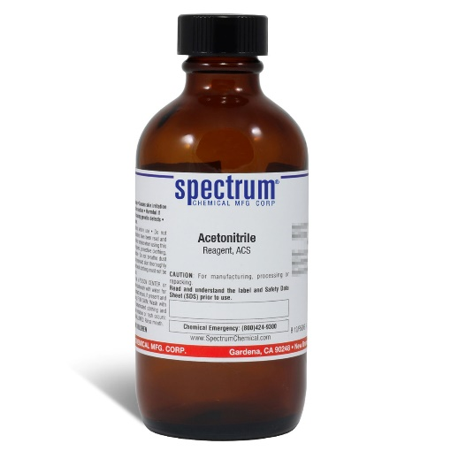
   2. What is the toxin associated with this product?
   3. What is its mechanism?
   4. List potential treatments.
3. A patient is rescued from a house fire. They are found unresponsive by EMS.
   1. What toxins are typically implicated in house fires?
   2. What are the mechanisms?
   3. What are potential treatments? How do they differ from the last case?
4. A patient is found unresponsive and apneic in a grain storage facility.
   1. What is the toxin?
   2. How does is cause toxicity?
   3. What is the treatment?

Journal Articles for Discussion:

We will follow with journal club and will be discussing the following two articles. Please assign a rotator to present each paper and all rotators should read both papers and be prepared to discuss.

1. Straus DG et al. Intranasal Naloxone Repeat Dosing Strategies and Fentanyl Overdose: A simulation Based Randomized Clinical Trial. JAMA Network Open 2024
2. Simon M et al. The role of QRS complex prolongation in predicting severe toxicity in single xenobiotic overdose. Clin Tox 2024

Zoom Meeting Details:

Please click this URL to start or join. <https://upstate.zoom.us/j/94022814635?pwd=ZXdZOFN3OFMrN1FjWlhOTGRid3YyUT09>

    Or, go to <https://upstate.zoom.us/join> and enter meeting ID: 940 2281 4635 and password: caseconf

Join from dial-in phone line:

    Dial: +1 646 876 9923 or +1 312 626 6799

    Meeting ID: 940 2281 4635

    Participant ID: Shown after joining the meeting

    International numbers available: <https://upstate.zoom.us/u/agSuvcevx>