Toxicology Case Conference

September 12, 2024

Location: 9th Floor Conference Room/Zoom

Time: 1:30-2:30 PM   
Leaders: Kolbeck/Stork

1:30 – 2:30 pm: Toxicology Case Conference  
2:30 – 3:30 pm: Journal Club

Case 1:

A 16 year old female presents to the ED shortly after she was witnessed to take a “handful of pills” by her mother. Her only home medications include lisdexamfetamine and sertraline though there are other over the counter medications in the home. On arrival, her vital signs are BP 126/86, HR 125 bpm, RR 22, SpO2 99% on RA. Her examination is notable for increasing confusion and agitation described as “picking.” A foley catheter is placed with output of 1.2L of urine. She is treated with IV fluids, lorazepam, diazepam, and is transferred to the children’s hospital for further management. Her labs are unremarkable including negative APAP, ASA, EtOH. EKG is pictured below.

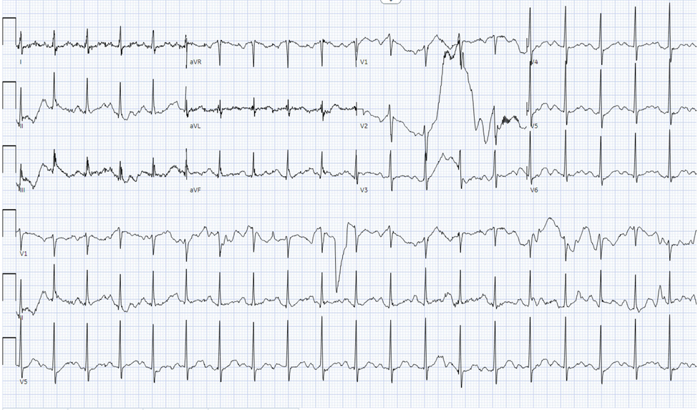

* What toxidrome is she most likely displaying? What other findings would you expect on exam?
* What treatments would you consider for this patient?

Case 2:

76-year-old female presents from home after a suspected overdose. Her home medications include sertraline, amitriptyline, metoprolol, famotidine, amlodipine, lisinopril, and potassium. She was found with several empty bottles. She was found with significant altered mental status and was intubated en route for airway protection. Her initial vital signs include HR 95 bpm, BP 80/40, RR 14/min, SpO2 99% on 100% FiO2. The remainder of her exam shows pupils 4 mm, hypoactive bowel sounds, no myoclonus or hyperreflexia. Her EKG is shown below.

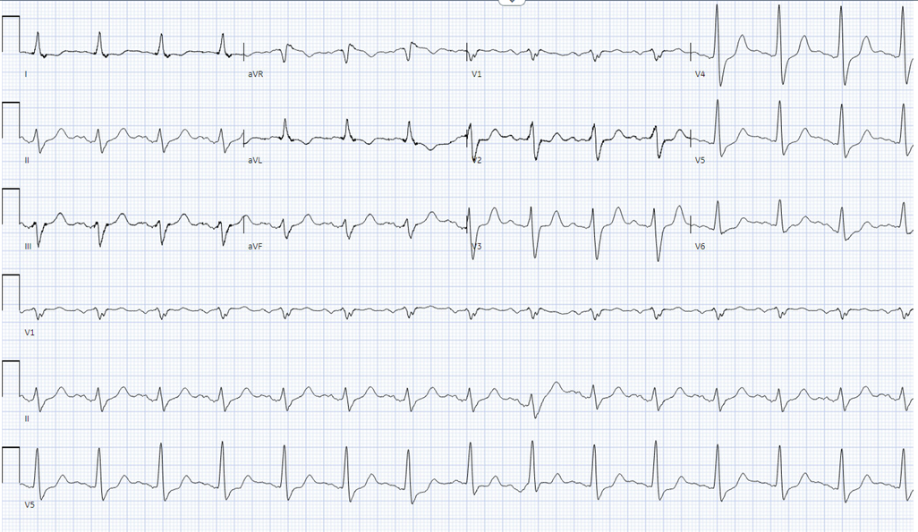

* What is your differential diagnosis for this patient, assuming the history of ingestion is accurate?
* What treatments would you consider? How would you guide ongoing treatment?
* What treatments are contraindicated?

Case 3

A 43-year-old female presents to the emergency department after an intentional overdose of a “handful of pills” witnessed by her mother who called EMS. On arrival, she is noted to have elevated BP (170 systolic), tachycardia (130 bpm), confusion, and had a tonic clonic seizure which was treated with benzodiazepines. She was treated with IV fluids for subsequent hypotension as well as boluses of sodium bicarbonate for EKG showing QRS of 108 msn without significant improvement. Her laboratory studies are notable for elevated WBC, elevated lactate (13) immediately following the seizure.

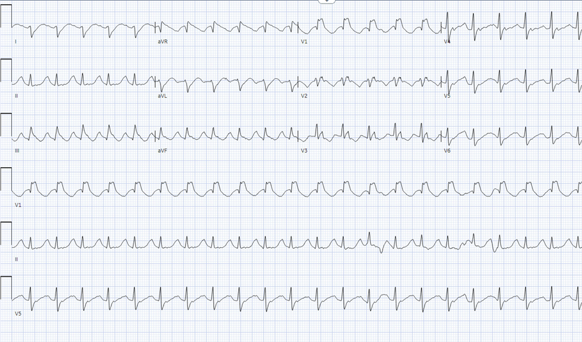

* Differential diagnosis?
* What treatments would you consider?

Journal Club:  
Articles attached   
1. Dillon DG, Montoy JCC, Nishijima DK, Niederberger S, Menegazzi JJ, Lacocque J, Rodriguez RM, Wang RC. Naloxone and Patient Outcomes in Out-of-Hospital Cardiac Arrests in California. JAMA Netw Open. 2024 Aug 1;7(8):e2429154. doi: 10.1001/jamanetworkopen.2024.29154. PMID: 39163042; PMCID: PMC11337064.

2. Rule JA, Ajayi F, James LP, Tujios SR, Sussman NL, Rakela JL, Ganger D, Bass NL, Reuben A, Stravitz RT, Lee WM; Acute Liver Failure Study Group. Differentiating Ischemic Hepatitis from Acetaminophen Overdose in Acute Liver Failure: Role of Acetaminophen Adducts-Ischemic Hepatitis vs Acetaminophen Overdose. Dig Dis Sci. 2024 Sep 2. doi: 10.1007/s10620-024-08602-7. Epub ahead of print. PMID: 39222204.

Zoom Meeting Details:

Please click this URL to start or join. <https://upstate.zoom.us/j/94022814635?pwd=ZXdZOFN3OFMrN1FjWlhOTGRid3YyUT09>

    Or, go to <https://upstate.zoom.us/join> and enter meeting ID: 940 2281 4635 and password: caseconf

Join from dial-in phone line:

    Dial: +1 646 876 9923 or +1 312 626 6799

    Meeting ID: 940 2281 4635

    Participant ID: Shown after joining the meeting

    International numbers available: <https://upstate.zoom.us/u/agSuvcevx>