Toxicology Case Conference  
December 12, 2024  
1:30 – 3:30 pm  
Location: Zoom (meeting details below) & In-Person 9th floor Jacobsen Hall

**Topics/Cases for Discussion:**

**Dr. Saunders’ Case**: What to pack for the astral plane? Looking at Ayahuasca and its cultural implications in psychedelic tourism.

**Dr. Rogers’ Cases:**

1.) Case 1: 54-year-old female presents to the emergency department via EMS with altered mental status. The patient’s family stated that she is known to have alcohol use disorder and drinks approximately 750 mL of vodka daily. They found her with an open, unlabeled bottle on the floor next to her.

* + Initial vital signs: HR 115, BP 130/70, RR 30, SpO2 97% RA, FSBS 82
  + On initial exam, patient is noted to be somnolent, not following any commands, she has rapid and deep respirations
  + VBG: pH 7.21, CO2 22, lactic acid 6.6, BMP: Na 143, K 4.1, HCO3 6, Cl 105, BUN 18, Cr 1.1, glucose 75, EtOH negative

Case 1 Discussion:

* + How do you interpret the VBG and BMP?
  + Construct a differential diagnosis for this presentation
  + Does a normal osmolar gap rule out the most likely diagnosis?
  + What are the toxic metabolites of the 2 most common substances in this ingestion
  + What are the major treatments for this ingestion?

2.) Case 2: A 14-month-old female presents to the emergency department after being found by her parents coughing and vomiting. The child’s mother had left her alone in the garage to check something inside of their home, and when she returned, the child was found in this state covered in a liquid with a very pungent odor. She presents to the ED with the following vital signs:

BP 85/50, HR 130, RR 40, T 37.5 C, 94% on RA

On exam, the child is awake and crying, notable nasal flaring and retractions on exam. She also has mild rhonchi on auscultation of the right lung.

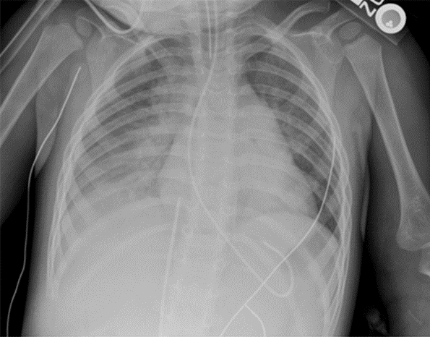

Case 2 Objectives and discussion:

* What features of the presumed chemical make aspiration more likely?
* What are the keys to management of this patient?
* What if she had been asymptomatic after the ingestion, when do you get the chest x-ray and how long do you watch her?

Journal Articles: Attached

1. Wallum M et al. Risk of Mortality among adolescents and young adults following hospitalization from an intentional overdose. Am J Emerg Med 2024 Nov 27; 88:140-144.
2. Dash S et al. Effect of a best practice advisory activated “kit in hand’ naloxone distribution program in the emergency department. Am J Emerg Med 2024 Nov 23; 88: 134-139

Zoom Meeting Details:

Please click this URL to start or join. <https://upstate.zoom.us/j/94022814635?pwd=ZXdZOFN3OFMrN1FjWlhOTGRid3YyUT09>

    Or, go to <https://upstate.zoom.us/join> and enter meeting ID: 940 2281 4635 and password: caseconf

Join from dial-in phone line:

    Dial: +1 646 876 9923 or +1 312 626 6799

    Meeting ID: 940 2281 4635

    Participant ID: Shown after joining the meeting

    International numbers available: <https://upstate.zoom.us/u/agSuvcevx>