Toxicology Case Conference  
January 2, 2025  
1:30– 2:30 pm   
Location: Zoom (meeting details below) & In-Person 9th floor Jacobsen Hall

Cases for Discussion:

**Case Conference 1/2/2025**

1. **A 52-year-old female presents to the emergency department in the Fall. She complains of abdominal discomfort, vomiting, and profuse diarrhea which began four hours after eating a soup of foraged mushrooms. Her vital signs show BP 170/129, HR 100 bpm, RR 18, SpO2 99% on RA. Now, approximately 10 hours after ingestion, she has ongoing vomiting and diarrhea. Her initial labs are notable for AST 67 U/L and ALT 86 U/L. She provides a photograph of some of the mushrooms used to prepare her soup.**
   1. 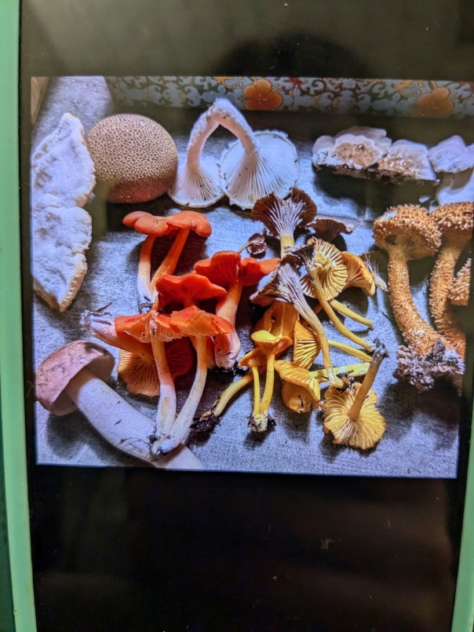c
   2. What do you suspect is the cause of her symptoms?
   3. How would you manage this patient?
      1. Describe at least 3 treatment options.
2. **A 71-year-old female presents to the emergency department because her Apple watch alerted her that her SpO2 was 70%. She is asymptomatic. Her initial vital signs show T 36.7°C, HR 92, BP 157/72, SpO2 85% on 15L NRB. On exam, she is awake, alert and oriented, lungs are clear, she is noted to have cyanosis. She adds that she is being treated for a UTI and has had considerable dysuria over the past day.** 
   1. What is the diagnosis and what medication is most likely responsible?
      1. What other medications are associated with this?
      2. Explain the pathophysiology.
   2. What testing would you consider and explain your rationale for interpretation.
   3. Based on the presentation and results of tests, what treatment(s) would you consider?
3. **A 15-year-old female is found unresponsive at home by her parents. On EMS arrival, she is found to be in cardiac arrest with ventricular tachycardia noted as the initial rhythm. She is defibrillated with 200 Joules with return of spontaneous circulation. On arrival to the emergency department, vital signs are notable for BP 90/42, HR 115 bpm, SpO2 97% on 100% FiO2, T 35.2°C. Her parents arrive shortly after reporting they found an empty prescription bottle in her room and suspect she may have overdosed. They add that she is otherwise healthy with no chronic medical problems but was recently diagnosed with a URI. Her EKG is provided below.**
   1. 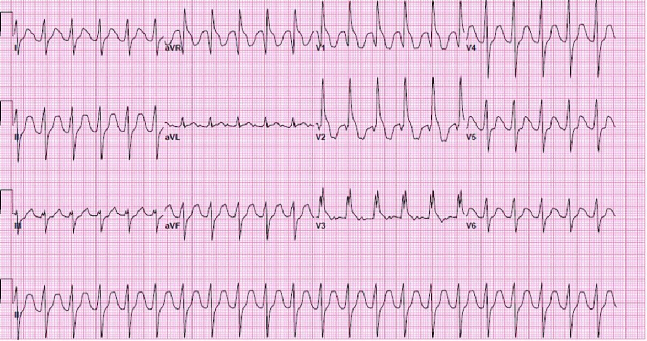
   2. What do you suspect is the etiology of her cardiac arrest?
   3. What other testing or treatment would you consider?

Journal Articles: Attached to email

Zoom Meeting Details:

Please click this URL to start or join. <https://upstate.zoom.us/j/94022814635?pwd=ZXdZOFN3OFMrN1FjWlhOTGRid3YyUT09>

    Or, go to <https://upstate.zoom.us/join> and enter meeting ID: 940 2281 4635 and password: caseconf

Join from dial-in phone line:

    Dial: +1 646 876 9923 or +1 312 626 6799

    Meeting ID: 940 2281 4635

    Participant ID: Shown after joining the meeting

    International numbers available: <https://upstate.zoom.us/u/agSuvcevx>