Toxicology Case Conference  
April 10, 2025  
1:30– 2:30 pm   
Location: Zoom (meeting details below) & In-Person 9th floor Jacobsen Hall

**Cases for Discussion:**

Case 1:

A 45-year-old male presented to the ED with hand and leg pain after finishing a day working on his hobby-restoring classic cars. He says earlier in the day he may have splashed some liquid on his leg but ignored it, assuming it to be water. About 30 minutes ago, he felt a burning sensation that progressed to severe pain. On arrival, he is in exquisite pain. Vitals are HR 92, BP 132/84, RR 16. A picture of his hand burn is below.

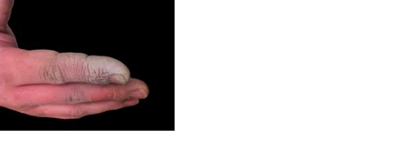

Objectives:

1. Identify the most likely agent and the constellation of symptoms that may present after a significant exposure.
2. Describe the laboratory findings that would be indicative of severe toxicity from this agent.
3. Explain the treatment and management of this patient in the ED.

Case 2:

A 29-year-old female presents to the emergency department reporting painful skin lesions that started on her LLE then progressed to involve her ears and digits. She reports infrequent cocaine use. Other associated symptoms include malaise, subjective fevers, and myalgias. Her physical exam is below:

VS: HR 102, BP 122/78, RR 16, T 38.1 C, SpO2 99%

HEENT: Tender pinnae with discoloration over tips.

Neuro: WNL

MSK: Mild tenderness over multiple joints.

Skin: Image below. Necrotic lesions also involve the ears, toes, and fingers .

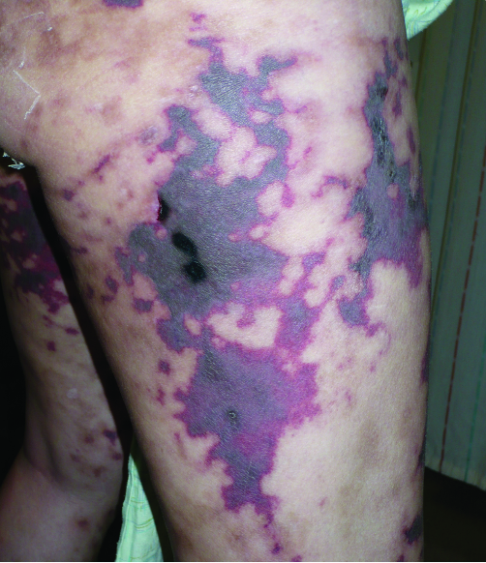

Objectives:

1. Describe the most likely exposure and the reason it may have been incorporated into the patient’s illicit drug supply.
2. Create a list of other potential adulterants found in the illicit drug supply.
3. Devise a treatment plan for this patient.

Case 3:

A 17-year-old female patient presents to the ED with complaints of rash, fever, and malaise for the last 3 days. The rash, pictured below, covers a large portion of her lower extremities and trunk.

**Journal Club: Articles attached**

Zoom Meeting Details:

Please click this URL to start or join. <https://upstate.zoom.us/j/94022814635?pwd=ZXdZOFN3OFMrN1FjWlhOTGRid3YyUT09>

    Or, go to <https://upstate.zoom.us/join> and enter meeting ID: 940 2281 4635 and password: caseconf

Join from dial-in phone line:

    Dial: +1 646 876 9923 or +1 312 626 6799

    Meeting ID: 940 2281 4635

    Participant ID: Shown after joining the meeting

    International numbers available: <https://upstate.zoom.us/u/agSuvcevx>