Toxicology Case Conference  
April 24, 2025  
1:30– 2:30 pm   
Location: Zoom (meeting details below) & In-Person 9th floor Jacobsen Hall

**Case 1:**

A 78-year-old male presents to the ED with dizziness, vomiting, and chest pain. He reports that he was out fishing with his grandson where they had eaten fish and foraged leeks for lunch.

Vital signs: BP 82/41, HR 45 bpm, RR 13, SpO2 96%

* What is your differential diagnosis?
* What additional testing would you consider?
* What treatments would you consider?

**Case 2:**

A 50-year-old patient presents after intentional ingestion of the mushroom pictured below. She presents to the emergency department with intractable vomiting and diarrhea 12 hours after ingestion. Vital signs are BP 100/70, HR 118, RR 18, SpO2 99%, T 37C

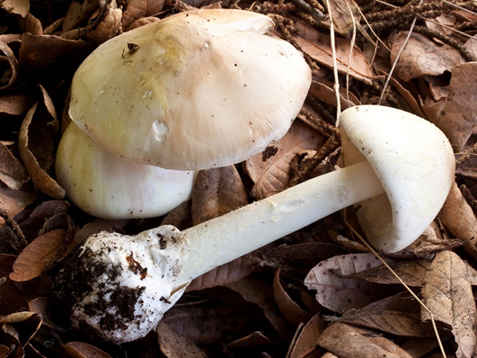

* What is the toxin
* How do you clinically distinguish toxic from non-toxic (or minimally toxic) mushrooms?
* Describe the various treatment options and their mechanisms

**Case 3:**

A child presents to the emergency department after eating ‘berries’ from a tree outside. You are provided a photo of the tree below.



* What is the plant, what part(s) is/are toxic?
* What is the mechanism of toxicity?
* What pharmaceutical medication is similar to this?
* What is the associated toxicity
* Treatment?

**Journal Club: Articles attached**

Journals:

1. Spungen HH, Sherman JM, Ryan K, Krueger JJ, Levine M, Spyres MB. Vasopressor Use,Critical Care Management, and Outcomes in Dihydropyridine Calcium Channel Blocker Toxicity. *J Med Toxicol*. Published online April 11, 2025. doi:[10.1007/s13181-025-01069-6](https://doi.org/10.1007/s13181-025-01069-6)
2. Gresnigt F, Van Essen J, Hunault C, Franssen E, De Lange D, Riezebos R. Comparative evaluation of the ability to detect major cardiac events with the modified cocaine history, electrocardiogram, age, risk factors and troponin (HEART) score, HEART pathway and original HEART score in patients with cocaine-associated chest pain presenting at the emergency department. *Clinical Toxicology*. Published online April 14, 2025:1-8. doi:[10.1080/15563650.2025.2472955](https://doi.org/10.1080/15563650.2025.2472955)

Zoom Meeting Details:

Please click this URL to start or join. <https://upstate.zoom.us/j/94022814635?pwd=ZXdZOFN3OFMrN1FjWlhOTGRid3YyUT09>

    Or, go to <https://upstate.zoom.us/join> and enter meeting ID: 940 2281 4635 and password: caseconf

Join from dial-in phone line:

    Dial: +1 646 876 9923 or +1 312 626 6799

    Meeting ID: 940 2281 4635

    Participant ID: Shown after joining the meeting

    International numbers available: <https://upstate.zoom.us/u/agSuvcevx>