Toxicology Case Conference
April 30, 2026
Location: Poison Center Conference Room / Zoom
Time: 1:30-3:30 PM
Leaders: Drs. Kolbeck/Rogers

Cases for Discussion:

Case 1
A 14-month-old female presents to the emergency department after being found by her parents coughing and vomiting. The child’s mother had left her alone in the garage to check something inside of their home, and when she returned, the child was found in this state covered in a liquid with a very pungent odor. She presents to the ED with the following vital signs:
BP 85/50, HR 130, RR 40, T 37.5 C, 94% on RA
On exam, the child is awake and crying, notable nasal flaring and retractions on exam. She also has mild rhonchi on auscultation of the right lung.
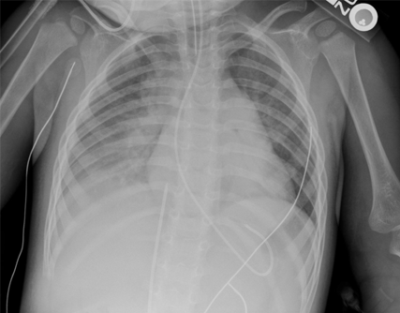
Case Objectives and discussion:
- What features of the presumed chemical make aspiration more likely?
What are the keys to management of this patient?
- What if she had been asymptomatic after the ingestion, when do you get the chest x-ray and how long do you watch her?

Case 2
A family of foragers presents to your ED reporting that they had made a stew last night containing the mushrooms pictured below. They reported that they had been looking for chanterelle mushrooms and believed that these looked similar to the chanterelles they saw on a Youtube video. They are complaining of epigastric abdominal pain, profuse vomiting, and watery, nonbloody diarrhea.
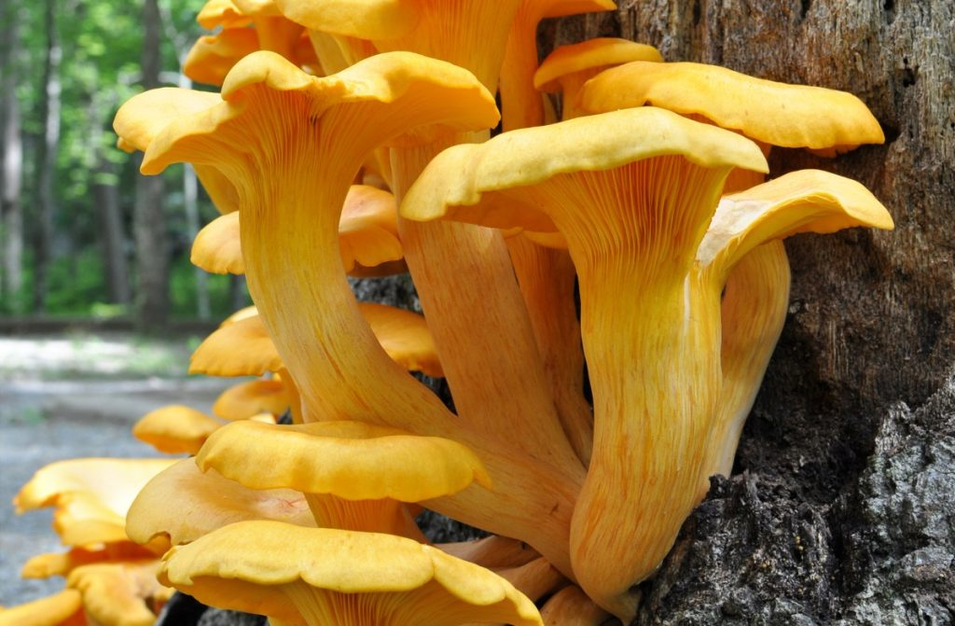
- Symptom onset how long after consumption would make you concerned about serious toxicity?
- How would you manage this patient? How long would you observe them for if they told you that their symptoms started 1 hour after ingestion?

Case 3
A 64-year-old gentleman presents to your ED complaining of profuse watery diarrhea, nausea and vomiting that began 6 hours after eating a meal with sautéed foraged mushrooms. He has minimal abdominal pain. His vital signs are HR 130, BP 110/62, RR 22, T 37 C. Initial labs are only notable for a slightly elevated Cr of 1.35 and AST/ALT 64/35. He brought in a single specimen which he believes was picked from the same patch as some of the mushrooms that he consumed.

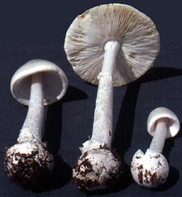

- What is the classic progression of symptoms for patients who consume this mushroom?
- What is the mechanism of toxicity from the above mushrooms?
- What are the 2 mainstays of treatment? What about adjunctive therapy?

Journals (immediately following):
See attached

Zoom Meeting Details:
Please click this URL to start or join. https://upstate.zoom.us/j/94022814635?pwd=ZXdZOFN3OFMrN1FjWlhOTGRid3YyUT09
Or, go to https://upstate.zoom.us/join and enter meeting ID: 940 2281 4635 and password: caseconf

Join from dial-in phone line:

Dial: +1 646 876 9923 or +1 312 626 6799
Meeting ID: 940 2281 4635
Participant ID: Shown after joining the meeting
International numbers available: https://upstate.zoom.us/u/agSuvcevx

