Toxicology Case Conference
December 21, 2023
Location: 9th Floor Conference Room/Zoom
Time: 1:00-3:30 PM

1:00 – 2:00 pm: ACMT National Case Conference
2:00 – 2:30 pm: Holiday Hazards Trivia
2:30-3:30 pm: Journal Club

Holiday Hazards Trivia
1. What is this? Name the toxin? What are signs/symptoms of toxicity? How do you manage? Name one other holiday product may contain this toxin?



2. What is the concern with this toy? What are two potential “new-ish” treatment options?

3. These can be used to change the color of your fireplace. Provide at least two chemicals that can be used to change the color. What is the toxicity of these chemicals?
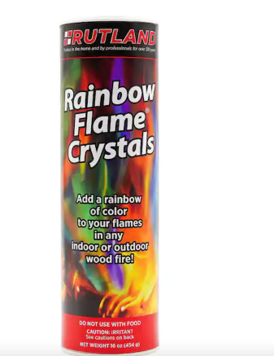

4. A child is found sitting with this product. There is evidence in his mouth of exposure but the parents are unclear how much the child ingested. What are the concerns?

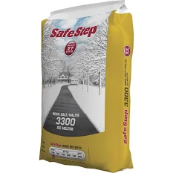

Journal Articles for Discussion:
- Adams A et al. Does occupational exposure to fentanyl cause illness? A systematic review. Clin Tox 2023
- Palamar JJ et al. Trends and correlates of discordant reporting of drug use among nightclub/festival attendees, 2019-2022. Clin Tox 2023

Zoom Meeting Details:
Please click this URL to start or join. https://upstate.zoom.us/j/94022814635?pwd=ZXdZOFN3OFMrN1FjWlhOTGRid3YyUT09
Or, go to https://upstate.zoom.us/join and enter meeting ID: 940 2281 4635 and password: caseconf

Join from dial-in phone line:

Dial: +1 646 876 9923 or +1 312 626 6799
Meeting ID: 940 2281 4635
Participant ID: Shown after joining the meeting
International numbers available: https://upstate.zoom.us/u/agSuvcevx

