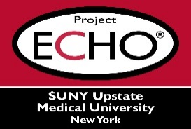
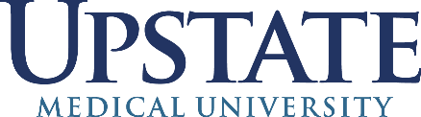

SUNY Upstate Project ECHO® (Extension for Community Healthcare Outcomes)

SUNY Upstate Toxicology TeleECHO
Emerging Trends in Substance Use
SUNY Upstate
Syracuse, NY
Tuesday, March 4, 2025
Noon - 1 PM

TARGET AUDIENCE:
Physicians, Physicians Assistants, Nurse Practitioners, Registered Nurses, Community Health Care Workers, Pre-Hospital Healthcare workers, Pharmacists, Emergency Care Providers

PRESENTER:
William Eggleston, PharmD

OBJECTIVES:
Participants will be able to:
- Identify recent trends in substance use of novel agents.
- Describe the pharmacology and potential medical complications of these agents.
- Discuss the challenges in detection and regulation of these agents.

ACCREDITATION: SUNY Upstate Medical University is accredited by the Accreditation Council for Continuing Medical Education (ACCME) to provide continuing education for physicians.
CREDIT DESIGNATION: SUNY Upstate Medical University designates this live activity for a maximum of 1.0 AMA PRA Category 1 Credits™. Physicians should claim only the credit commensurate with the extent of their participation in the activity.
PLANNER DISCLOSURES: J. Marraffa, K. Donovan do not have relevant financial relationships with ineligible companies.
SPEAKER DISCLOSURE: W. Eggleston does not have relevant financial relationships with ineligible companies.
MITIGATION: All listed relevant financial relationships have been mitigated.
COMMERCIAL SUPPORT: No commercial is received for this CME program.

