1. **Dr. Jaclyn Sisskind, MD**

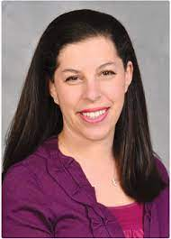

Is the Medical Director of General Pediatrics and a practicing pediatrician at SUNY Upstate Medical University.  She is such a passionate believer in the power of stories and the act of reading to enhance children's lives that she's been dubbed the "Readiatrician."  Sisskind doles out prescriptions at every office visit, but she doesn’t just prescribe pills to chew or liquids to swallow; she prescribes books.

ForSisskind, the pages of a book are perhaps the most important tool in her medical bag. She uses them as a diagnostic tool to check the developmental milestones of babies, the social-emotional intelligence of toddlers and to help teens find their bearings. Sisskind has her own website, 15,000 followers on Twitter, and hosts a monthly virtual book club called PediaLit for local pediatricians.

She has connected with authors, spoken at reading conferences, written several blog posts about her experiences, and contributed to School Library Journal. Sisskindspends her days seeing patients, teaching medical students, and calculating if she has time to stop at the library on her way home. She lives in upstate New York with her best friend, who is also her husband, and their three sons.

1. **Dr. Kaushal Nanavati**, MD FAAFP, ABOIM, ABIHM E – Engaging Lecturer

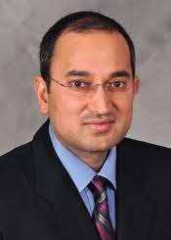

Assistant Dean of Wellness, Director Integrative Medicine and Survivorship, Upstate Cancer Center, Assistant Professor Family Medicine- Upstate Medical University

I am a motivational speaker, an integrative family physician, and an author with a passion for leading people toward improved wellness, self-care, and peace in life. I have written for local magazines; taught end-of-life care to physicians, families, and caregivers; and worked in rural, suburban, and urban settings. I believe that overall wellness is a primary means of disease prevention.  
  
 Originally born in India, I moved to Rochester, New York, as a child and eventually earned my biology degree, with minors in philosophy and literature, at Rensselaer Polytechnic Institute. I also attended St. George’s University School of Medicine.

Dr. Nanavati is the author of [*CORE 4 of Wellness: Nutrition | Physical Exercise | Stress Management | Spiritual Wellness*](https://www.amazon.com/CORE-Wellness-Nutrition-Management-Spiritual/dp/1530256720/ref=sr_1_1?crid=P3WLWCN6H8Z7&keywords=kaushal+nanavati&qid=1677672316&sprefix=nanavati%2Caps%2C134&sr=8-1)

1. **T.J. Raphael**

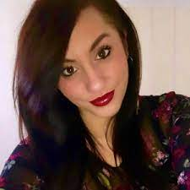

T.J. Raphael ’11 (journalism, political science minor) is host and senior producer at Sony Music Entertainment. She’s a reporter, producer, sound designer, and host of productions including: “Broken: Jeffrey Epstein”, “VIRAL”, and “Do the Work”.

After years of research, she’s telling the story of unexpected DNA testing results in a new podcast, [**BioHacked: Family Secrets**](https://podcasts.apple.com/us/podcast/biohacked-family-secrets/id1607121653), which was Apple Podcast’s Pick of the Week on March 18, 2022, and landed on Apple’s New and Noteworthy list the following week.

BioHacked: Family Secrets:  dives into the complexities of the fertility industry and chronicles how real people’s lives are transformed by evolving technology.

The podcast follows the children of anonymous sperm and egg donors as they uncover the identities of their donors and gather vital medical information. Unexpected ethical, scientific, and political challenges arise that question all aspects of the baby business.

1. **Thomas Hirasuna & Diane Stefani –** Climate Reality Project

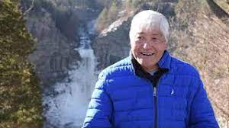 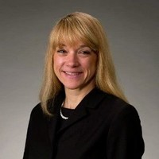

Arguably the greatest challenge of our time is climate change and how we respond to it. Tom and/or Diane would discuss climate change’s current and future effects on public health and our healthcare systems. Focusing on where we are, where we need to be, and ideas on how we get there. Their goal is to ignite activism.

Tom currently serves as Chapter Co-Chair. He has been encouraged by the Chapter’s growth to over 100 members and would like to see continued member participation. He aims to improve collaboration with our legislators and other climate/environmental groups within our region. Tom was trained in Atlanta in 2019 and has served as a Mentor for 3 Climate Reality Leader trainings. Originally from Honolulu, he has lived in Ithaca since 1985 and has been a NYS resident and voter since 1977. He is also on the ExCom of the Finger Lakes Group (FLG) of the Sierra Club Atlantic Chapter and a Board Member of Cornell Cooperative Extension Tompkins County (CCETC). He has academic degrees from MIT, Columbia, and Cornell. He is a registered PE in NYS and is a retired food product/process development consultant.

Outside of his advocacy role, Tom plays trumpet with the Ithaca Concert Band (ICB) and the Ithaca Community Orchestra (ICO).

Diane is committed to the future of our children, wildlife, and the environment. She is a trained leader (2020) for the Climate Reality Project (CRP) and is a Chapter Co-Chair. Diane is a retired business and Human Resources leader. She received bachelor’s and master’s level business degrees from Binghamton University and the University of Tennessee, Knoxville.

Diane engages locally as the chair of the Broome County Environmental Management Council. She is on the executive board of Tier Energy Network (TEN), a coalition of energy interests, and on the TEN Workforce Development team. Diane volunteers as an Energy Navigator for Cornell Cooperative Extension, Energy Programs, and the Southern Tier Food Bank.

Diane and her husband Gary love roaming the public lands near their upstate New York home.

1. **LLana James**

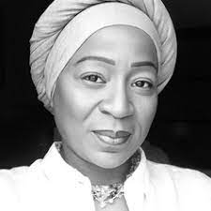

LLana James is the AI, Medicine, and Data Justice Post-Doctoral Fellow at Queen's University. She is also wrapping up her doctoral studies at the University of Toronto, Faculty of Medicine. Her research is focused on the intersection of AI applications in, clinical care, population health, public health data science and the law, and its particular implications for BlackLife. LLana’s recent thinking and research can be found in the Globe and Mail, The Conversation, the Toronto Star, the AI Health podcast, and the web series COVID Conversations, which is the first and longest-running pan-Canadian series on race-based data collection, AI, Big Data, privacy, ethics and equity in health.

1. **Suzanne Brisk –** Interactive

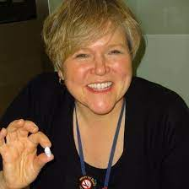

Pathway to Wellness Coordinator at Upstate Medical University. Experienced Wellness Professional. 20+ years of experience designing, implementing and evaluating employee wellness programs. A highly energetic, enthusiastic promoter of wellness and lifestyle improvement.

Suzanne plans, coordinates, and implements the Pathway to Wellness program at Upstate. She researches and implements wellness programs for the students and staff at Upstate. She serves as a wellness expert for local radio, TV, and newspaper wellness and health education topics. She also studies and presents health education on a variety of topics to diverse populations.